North Carolina
Foundations of Youth
Prevention Education
2018 Participant Guide

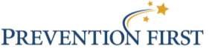

This training was modified and adapted with permission from Prevention First, a nonprofit dedicated to preventing teen drug use before it starts.
Prevention First provides a wide array of substance abuse prevention services geared at building prevention capacity, promoting best practices, training prevention professionals, and increasing public awareness of the importance of prevention.
For more information about Prevention First, visit www.prevention.org.

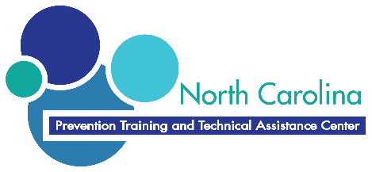

North Carolina Training and Technical Assistance Center

The North Carolina Training and Technical Assistance Center works to prevent substance abuse and promote wellness by providing technical assistance, training and resources to increase the effectiveness of communities and prevention professionals to strategically implement research-based programs, best practices and policies.
The Center is located in Winston-Salem, NC and serves the state and all statewide funding streams. The Center employs highly trained staff to assist with technical assistance and provide trainings to support a strong prevention workforce in NC.
The Division of MH/DD/SAS is invested in providers doing good work and advancing prevention toward successful outcomes. Supporting the work of prevention professionals is at the heart of healthy communities in North Carolina.
DMH/DD/SAS provides support for these TA services and receives aggregate reports on TA successes. DMH/DD/SAS also looks to the TA system to identify common challenges for prevention providers that may need system-wide attention. Providers may contact their LME-MCO and the DMH/DD/SAS with any questions, especially those relating to funding, development or submission of budgets and understanding of directives.
This training content is Division approved and adheres to Standards of Effectiveness for Substance Abuse Prevention Programs.

www.nctraining.info

Table of Contents

Training Introduction
Training Overview.....................................................................................................6
Background Information........................................................................................8
Requirements for YPE.............................................................................................10
Setting Norms with Your Students…................................................................15

Module One

Planning and Managing the Program
YPE Skills.....................................................................................................................17
Promote the Strategy.............................................................................................19
Activity: Learning Standards Alignment.....................................................32
Develop and Foster Collaboration…………...................................................33
Activity: Elements of Effective Collaboration............................................35
Negotiate a Strong Agreement.........................................................................46
Activity: Scenarios................................................................................................52

Module Two

Creating Effective Classroom Environments
Activity: Adolescent Development......................................................................60
Create an Effective Classroom Environment..................................................62
Fidelity and Adaptation………………………………………………………………..64

Module Three

Evaluating, Monitoring, and Reporting YPE
Evaluate the Program................................................................................................76
Activity: Evaluation Matching...............................................................................84

Appendix: Foundations of Prevention Education
Brainteaser 16, 14, 38...................................................................................................90
Alphabet Brands..............................................................................................................91
Creative Problem Solving............................................................................................92
Nine Dots............................................................................................................................93
Wordles................................................................................................................................94
Alphabet Sequence…………….……………………………………………………………..95
Blind Line Up.....................................................................................................................96
Prevention Rock Band……..………………………………………………………………..97
Group Break Out Sessions….……………………………………………………………..98

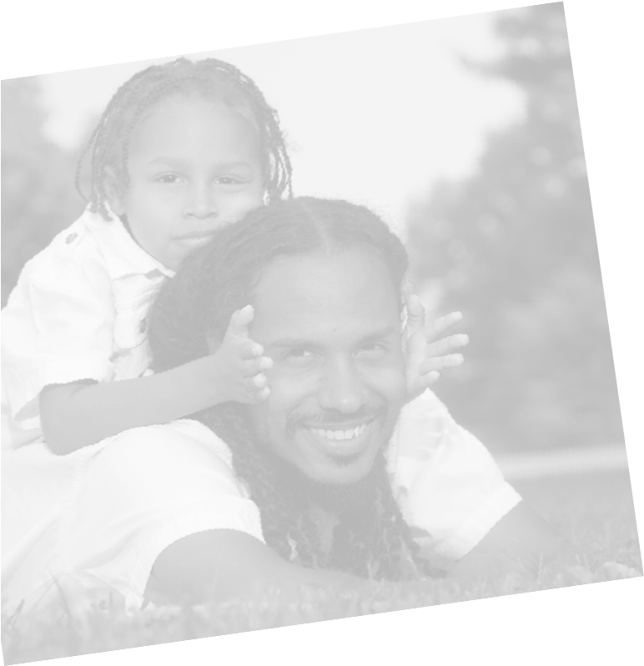

Training Introduction

Training Overview

Course Description
North Carolina Foundations of Youth Prevention Education prepares direct service providers to implement evidence-based and/or standards-based Youth Prevention Education (YPE) programs. North Carolina Foundations of Youth Prevention Education provides a basic understanding of the components and best practices related to implementing any YPE program. This training will increase participants’ knowledge and skills related to planning, managing, facilitating, evaluating, and monitoring a Youth Prevention Education program.

Learning Objectives
At the end of this course, direct service providers will be able to:
- explain the role of prevention professionals when facilitating school or community based programs,
- describe strategies for administering a collaborative YPE Program,
- identify specific strategies to develop strong agreements with schools for implementation of a multi-year program,
- describe strategies for working with youth using the principles of adolescent development,
- describe ways to create effective classroom environments,
- recognize facilitation techniques to engage students and manage participation,
- recognize the components of implementation criteria,
- relate how to implement a YPE program with fidelity and identify appropriate adaptations,

identify components of process and outcome evaluation to assess program effectiveness, and
- understand how to remain in compliance, manage, and report on YPE programming.

Training Overview [continued]

Intended Audience
This course is intended for Substance Abuse Prevention Block Grant (SAPBG) providers funded through the NC Substance Abuse Prevention and Treatment Block Grant (NCSAPTB). This training will satisfy the training requirement for Youth Prevention Education programs. Additional program-specific preparations will maximize a Provider’s ability to implement a chosen evidence-based program. Providers have an additional obligation to meet any of the requirements for training set forth by the developer of the program they choose to implement.

Outline of Course Contents
- Training Introduction
- Module One: Planning and Managing the Program
- Module Two: Creating Effective Classroom Environments
- Module Three: Evaluating YPE, Compliance, Monitoring, and Reporting
- Post-Training
Completion Time
The length of this program is 12 hours.

Background Information
Youth Prevention Education is one of many evidence-based substance abuse prevention strategies funded through the North Carolina Department of Health and Human Services. YPE uses ATOD Universal, Selective, or Indicated evidence based prevention curricula designed to increase prevention-related drug knowledge and resistance skills among youth under age 18.
Research has uncovered a great deal about the factors which significantly increase risk of developing alcohol or other drug problems for millions of children. Substance abuse by a parent, lack of parental guidance, or a disruptive, abusive family are very strong predictors, as are school failure, early experimentation with drugs, and living in a community where substance abuse and dealing are pervasive.¹ Children facing multiple risks are much more likely to move from experimentation to serious substance abuse by the time they are teenagers.^{2,3}
Youth prevention education programs are designed to address different levels of risk. Universal interventions, like drug education, target all youth without identifying those at particularly high levels of risk. Selective interventions concentrate on those who are particularly vulnerable to drugs because of personal, family, and community risk factors, such as children who are poor school achievers.⁶ Indicated interventions concentrate on those who already engaged in initial substance use. Depending on the targeted population, prevention messages range in intensity.
Effective youth prevention education curricula teach young people to resist drugs by developing personal and social skills, such as decision making, stress management, communication, social interaction, conflict resolution, and assertiveness. In addition, these programs can enhance awareness and resistance skills. Students learn that most of their peers do not use drugs, and they learn to recognize social and peer influences on drug use. With this new awareness, youths are better able to resist the pressure to use drugs.⁴

YPE Background Information [continued]
Prevention efforts should begin early and continue through adolescence, when pressure to drink, smoke, and use other drugs greatly increases. Without reinforcing skills and anti-drug norms, behavioral results diminish. Programs enhanced with “booster sessions,” activities which follow up on the initial program, help prevent or delay the initiation of drinking, smoking, and using other drugs.⁴ Delayed initiation is beneficial, giving children time to develop social competence and resistance skills.
According to Making the Grade: A Guide to School Drug Prevention Programs,⁴ successful YPE programs incorporate a variety of key elements:
- help students recognize internal pressures, like anxiety and stress, and external pressures, like peer attitudes and advertising, that influence them to use alcohol, tobacco, and other drugs;
- develop personal, social, and refusal skills to resist these pressures;
- teach that using alcohol, tobacco, and other drugs is not the norm among teenagers, even if students believe that “everyone is doing it;”
- provide developmentally-appropriate material and activities, including information about the short-term effects and long-term consequences of alcohol, tobacco, and other drugs;
- use interactive teaching techniques, such as role plays, discussions, brainstorming, and cooperative learning;
- cover necessary prevention elements in at least ten sessions a year (with a minimum of three to five booster sessions in two succeeding years);
- actively involve the family and the community; and
- include teacher training and support, and contain material that is easy for teachers to implement and culturally relevant for students.

References:
- Understanding Substance Abuse Prevention, Toward the 21st Century: A Primer on Effective Programs. Center for Substance Abuse Prevention, Monograph, 1999.
- J. David Hawkins, “Risk Focused Prevention: Prospects and Strategies,” Presentation to the Federal Coordinating Council on Juvenile Justice and Delinquency Prevention, June 23, 1989.
- Barry S. Brown and Arnold R. Mills, eds., Youth at High Risk for Substance Abuse, Rockville, MD: National Institute on Drug Abuse, 1987.
- Making the Grade: A Guide to School Drug Prevention Programs. Drug Strategies, 1999.
- Bridget Grant and Deborah Dawson, “Age at Onset of Alcohol Use and Its Association with DSM-IV Alcohol Abuse and Dependence: Results from the National Longitudinal Alcohol Epidemiologic Survey.” Journal of Substance Abuse, 9:103-110, 1997.
- Preventing Drug Use Among Children and Adolescents: A Research-Based Guide. National Institute on Drug Abuse, 1997.
Requirements for YPE

Guidelines for YPE programs are located in the State ATOD YPE Guide in the Appendix.
Each staff member delivering the program must have completed the YPE training through the Centers for Prevention Resources. Each staff member assigned to the program completes the appropriate training for the curriculum, which may include formal training provided by the selected model program developer or a combination of preparation through mentoring and on-the-job training provided by a staff person with documented experience delivering the program. Providers who are implementing Youth Prevention Education programs have the opportunity to select from the list of pre-approved evidence-based programs listed below. If programs will be used that are not on the pre-approved list- they must adhere to the standards, and be approved by the Division.

YPE programs in the NC substance abuse prevention system fall into one of two categories:
- Current evidence-based curricula approved for use by the NC Substance Abuse Prevention Block Grant Department. These programs are on SAMHSA’s NREPP. All substance abuse prevention model program and evidence based training must be coordinated through the Substance Abuse Prevention Block Grant Manager at the NC State Prevention Office (please see the current master grid for the most recent list):
- HALO (HEALTHY ALTERNATIVES FOR LITTLE ONES) 0-5 Universal
- GUIDING GOOD CHOICES 8-14 Universal
- UNIQUE YOU (FORMERLY I’M SPECIAL), 3rd-4th Universal, Selective
- MEDIA READY 11-14 Universal
- MEDIA DETECTIVE, 6th-8th Universal
- ALL STARS 11-14 Universal, Selective
- ALL STARS JR 4th-5th Universal, Selective
- STORYTELLING FOR EMPOWERMENT 6-12 Selective
- PROJECT TND 14-19 Selective
- PROJECT ALERT 13-17 Selective
- EARLY RISERS 6-12 Selective
- RECONNECTING YOUTH 13-17 Selective, Indicated
- PROJECT SUCCESS 13-17 Indicated
- EARLY RISERS, 1st-5th Selective, Indicated
- Some providers may have developed a standards based program for a unique population to be used with their local community. These programs will require approval for use by the Substance Abuse Prevention Block Grant Manager in the NC State Office of Substance Abuse Prevention. Any developed curricula to be used at the local community level should meet the YPE Standards (see next page). The Standards for YPE were developed based on extensive research review. They reflect best practice for the strategies that are tied to program outcomes. An approval process is in place to request approval for other prevention education programs. Please also remember that there is a mandatory modified substance abuse prevention record that must be opened on each child (does not apply to Universal Programs)

Requirements for YPE [continued]
Standards for a Universal Population:
- Develop or obtain a written, planned curriculum that:
  - Includes a minimum of eight sessions in the first year (core level) and a minimum of five booster sessions for one or more of the following years.
  - Schedules each core and booster session for a minimum of 30 minutes in length.
  - Implements both core and booster session no more often than two times a week (i.e. cannot deliver the core or booster portion of program in a severely condensed format).
  - Does not include scare tactics designed to “shock” participants (e.g., mock crashes).
  - Does not include testimonials by former/recovering addicts.
- Develop/adapt materials and activities to ensure they are culturally sensitive/relevant and suitable to the age and development of the youth being served (e.g. language/reading level translation, incorporation of the perspective, values, social/emotional development and norms of the population).
- Focus the majority of program session time on interactive activities that include such techniques as role-plays, discussion, and cooperative learning (i.e. small group interactive educational tasks).
- Include the following content components for 4th & 5th grade youth:
  - Self-control (e.g. recognizing and coping with anxiety, anger, and impulses).
  - Emotional awareness (e.g. recognizing and understanding one’s own emotions).
  - Communication & social problem solving (e.g. expressing emotions effectively, handling interpersonal conflict).
  - Goal setting and attainment (e.g. focusing on tasks at hand, setting short-term and long-term goals, modifying performance based on feedback).
5. Include the following content components for 6th-8th grade youth:
- Coping with internal pressures such as anxiety, stress, and other internal factors that influence ATOD use (e.g. low self-esteem, psychological distress).
- Coping with external pressures (e.g., peer attitudes, peer pressure) through drug refusal skill-building.
- Factual information that reinforces the belief that ATOD use and/or abuse is not the norm or typical behavior for youth.
- Reinforcement of anti-drug attitudes.
- Strengthening of personal commitment against drug abuse.
- Short-term consequences (bad breath, financial cost, legal risks) associated with ATOD use.
- Communication skills (e.g., active listening, using “I” messages).
- Peer relationships (e.g., working as part of a team, showing sensitivity to social cues, harmonizing diverse feelings and viewpoints).
- Self-efficacy and assertiveness (e.g., exercising assertiveness, leadership and persuasion, recognizing self-strengths).

Standards for a Selective Population:
YPE programs that specifically target youth because they share a common risk (e.g. academic delay, developmental delay, behavioral disorders, etc.) are called “selected” programs, rather than “universal” programs. In addition to following the standards stated above (for universal programs), Youth Prevention Education programs that target a selected population must adhere to the following additional standards.
1. Develop or obtain a written, planned curriculum that includes a minimum of 20 sessions in the first year (core level) and a minimum of 10 booster sessions for one or more of the following years.
- Assure that staff who facilitate the program receive training in effectively working with youth that share the common risk factor(s) in the targeted population. For example, if the students are selected into the program because they have a behavior disorder, staff training should include strategies for encouraging effective learning in students with behavior disorders.
- Demonstrate a plan for parent/guardian involvement that includes:
  - A minimum of one interactive communication (e.g. phone call, face-to-face conversation, email dialogue) with at least one parent/guardian of each child in the program. The purpose of this communication is to discuss the child’s strengths, any challenges and progress during the program.
  - At least two opportunities for parent/guardian to receive information, provide input into the program, and have their questions addressed (e.g., parent night, e-mail/mail/phone calls, newsletters).
  - At least two in-home learning activities such as homework activities, parent/guardian-child discussion strategies, and at-home goal setting to reinforce the YPE curriculum content.
  - A description of how the cultural styles of families have been acknowledged so that information and outreach is culturally sensitive and appropriate (e.g., information is available in parent’s/guardian’s first language).
Standards for an Indicated Population:
YPE programs that specifically target youth because they are already engaged in initial substance use are called “indicated” programs. Depending on the targeted population, prevention messages range in intensity.
Indicated prevention interventions identify individuals who are experiencing early signs of substance abuse and other related problem behaviors associated with substance abuse and target them with special programs. The individuals identified at this stage, though experimenting, have not reached the point where clinical diagnosis of substance abuse can be made. Indicated prevention approaches are used for individuals who may or may not be abusing substances but who exhibit risk factors such as school failure, interpersonal social problems, delinquency, and other antisocial behaviors, and psychological problems such as depression and suicidal behavior, which increases their chances of developing a drug abuse problem. In the field of substance abuse, an example of an indicated prevention intervention would be a substance abuse program for high school students who are experiencing a number of problem behaviors, including truancy, failing academic grades, suicidal ideation, and early signs of substance abuse. The evidence-based curriculum “Reconnecting Youth,” which is designed for high school students is very effective and approved for high school credit
In addition to following the standards stated above (for universal and selective programs), Youth Prevention Education programs that target an indicated population must adhere to the following additional standards.
1. Develop or obtain a written, planned curriculum that includes a minimum of 20 sessions in the first year (core level) and, if booster sessions are included in the program model, includes a minimum of 10 booster sessions for one or more of the following years.
2. Assure that staff who facilitate the program receive training in how to effectively work with youth that share the common risk factor(s) of the targeted population. For example, if the students are selected into the program because they are experimenting with alcohol, tobacco or other drugs, staff training should include knowledge of the effects of ATODs, family dynamics and psychoeducation strategies.
3. Demonstrate a plan for parent/guardian involvement that includes:
• A minimum of one interactive communication (e.g. phone call, face-to-face conversation, email dialogue) with at least one parent/guardian of each child in the program to discuss the child’s strengths, challenges and progress.
• At least two opportunities for parent/guardian to receive information, provide input into the program, and have their questions addressed (e.g., parent night, e-mail/mail/phone calls, newsletters).
• At least two in-home learning activities such as homework activities, parent/guardian-child discussion strategies, and at-home goal setting to reinforce curriculum content.
• A description of how the cultural styles of families have been acknowledged so that information and outreach is culturally sensitive and appropriate (e.g., information is available in the parent/guardians first language).

Setting Norms with Your Students
Setting norms with the class gives teachers the chance to create an inclusive classroom environment through which all student voices are heard and honored. Teachers who establish and maintain norms for an effective learning environment spend more time teaching because less time is usurped by discipline (Brophy, 2000). Norms are more inclusive than “rules,” setting the stage for agreement about how the classroom should function, positive interaction, establishing reliance on each other and a respectful environment. The following protocol can be used to set group norms with students.

Purpose
To establish expectations for behavior and to give “permission” for risk-taking and full participation.

Time
This can take 10 minutes or an hour, depending on how deeply the facilitator and the group want to go.

Steps
Brainstorming: All ideas are listed; facilitator can add own. Allow silence at the beginning.
Discussion: Acknowledge that this is only a brainstormed list; the facilitator invites discussion/questions.
Synthesis: The facilitator helps form norms where there may be some disagreement—“Can we agree to use judgment about use of cell phones?”
Consensus: The group agrees to use these norms and revisit them regularly. Students could indicate their agreement verbally, by signing and displaying the norms or in some other manner.
When setting norms with a class it is important to hear all voices. It might be a good idea to give students time to think and write about how they wish to be treated and what norms they would like to see put in place. Next have the entire class brainstorm. This method provides a greater opportunity for participation, even from the shyest students.

