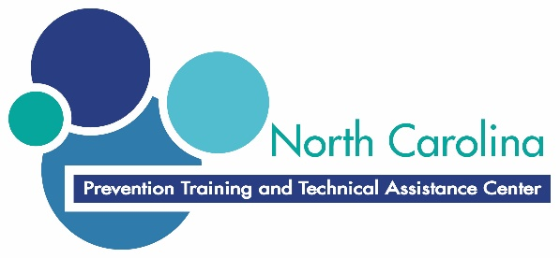

Youth Prevention Education (YPE)
Day 1 Evaluation
- What did you enjoy most about today?

- What did you learn during today’s sessions that you anticipate using in your work?

- Was there anything you did not understand during today’s sessions? Please provide specific examples.

- What is the most valuable thing you learned today (knowledge or skills?

- What other specific comments do you have?

