Module One:

Planning and Managing the Program

YPE Skills
Preventionists are not “just facilitators” of a YPE program. While some facilitators might think their job starts and ends in the classroom, most facilitators fulfill a variety of roles that require a complex set of skills.

Promote the Strategy
Whether the program is still in the planning stages or years into implementation, facilitators must often advocate for the YPE program they are administering. Facilitators may be relied on to get a new school or community organization to partner as a host site, convince an administrator, teacher or parent advocate that YPE and/or the program is effective, or present to the school board. An effective facilitator needs to know the selling points of youth prevention education and how to relay them in any context.

Develop and Foster Collaborations
Facilitators are ambassadors of their agency and the program. Facilitators are in the classroom setting on a regular basis, interacting with school (or other agency) partners frequently. They must be able to foster positive relationships with all site partners, from administrators to students and everyone in between. Perceived negative interactions can be destructive to the relationship – and the program.

Negotiate a Strong Agreement
A facilitator should be able to negotiate or renegotiate a strong agreement that balances meeting the program’s objectives, implementation criteria and the school’s/partner’s needs. The terms of the linkage agreement (including the program used, the schedule, each party’s responsibilities etc.) should be determined collectively by both parties. The agreement should be documented in writing.

Create an Effective Classroom Environment
YPE facilitators must be able to creatively and dynamically deliver the curriculum and connect with the students they teach. It is a facilitator’s job to create an environment conducive to learning where students are receptive and excited to learn. To create an effective environment, the facilitator must focus on outcomes by implementing the evidence-based curriculum with fidelity, plan lessons that will engage students and facilitate the process of learning by managing student participation and behavior.

Evaluate the Program
While the evidence-based programs being used have already been proven to be effective, process and outcome evaluation is still important at the local level. Gaining students’ reactions to the program can help identify areas where modifications are needed and/or facilitation could be improved. Gaining feedback of site partners (schools or other agency) tells you how the program is working for them, and its’ strengths and weaknesses from their perspective. Finally, most curricula come with a pre- and post-test that can help the program collaborators determine whether the program is effective in their setting.

Promote the Strategy
One responsibility of implementing a YPE program is to “make the case” – to school and community partners (administrators, teachers, parents, stakeholders etc.) – that youth prevention education programs provide students with knowledge and skills they need to succeed. YPE programs increase prevention-related drug knowledge and resistance skills thereby reducing associated risk factors and increasing the protective factors that make it more likely that a young person will abstain from ATOD use. They include components such as social skills development, peer and media pressure resistance, anti-drug attitudes and norms, and effective self-management skills in an effort to increase youth skills in dealing with high-risk situations and decreasing the potential motivation to use drugs.
Despite evidence that the health needs of students are both increasing and becoming more complex, prevention programs are not yet firmly rooted in public school systems. The nation’s public schools are under enormous pressure to improve the academic skills of students, especially in the core areas of language and mathematics. This pressure has resulted in the fairly widespread attitude among school officials that prevention programs are not critical and consume valuable time that could otherwise be devoted to academic instruction. By highlighting how safe and drug-free schools can enhance effective learning and teaching, YPE facilitators will be better able to garner the programmatic support they need to implement and sustain school-based prevention programs.
Three key concepts are important when promoting YPE with school or community partners:
- YPE can decrease ATOD related risk factors and increase protective factors
- YPE can help improve student academic performance
- YPE can help schools meet state standards

Promote the Strategy [continued]
Below is an outline you can use to develop a presentation or talking points with school or community partners:

I. YPE can decrease ATOD related risk factors and increase protective factors
Data helps to demonstrate the need for YPE and other prevention programs. By providing information about the extent of youth ATOD use and associated risk factors present in the community, school partners develop a clear understanding of the problem that needs to be addressed.
Statistics such as past 30-day use of most widely-used substances (alcohol, tobacco and marijuana) help stakeholders understand the extent of the problem in their community. Community needs assessments should use data, but also local data that illustrates the presence of risk factors such as favorable attitudes toward ATOD use, misperceptions of peer ATOD use and perceptions that ATOD use is not harmful can help demonstrate the need for prevention.
YPE programs can decrease risk factors and increase protective factors related to personal and social skills, awareness and resistance skills, perceptions of peer use and disapproval, as well as social and peer influences. The evidence-based programs on the approved list have been rigorously evaluated and shown to produce expected positive results. Each program boasts its’ own benefits and outcomes related to specific risk and protective factors. Schools and community organizations should be partners in selecting an appropriate program that addresses the specific problem(s) and risk factors present in the school/community.
Local program data – if available – can also help you demonstrate effectiveness with your audience if you have evidence that a program you have been using is achieving the desired outcomes. A history of positive results can help improve buy-in and sustainability. Most programs have tools available to evaluate the effectiveness of the program at a local level.

II. YPE can help improve student academic performance
Students engaging in substance use are more likely to miss school, be suspended or become truant. These “lost days of learning” diminish the allotment of general state aid for schools, which is based on average daily attendance rates.
As schools are being pressured to do more with less, they may be more likely to support prevention programs if they understood how they contribute to academic achievement. Evaluation results show that many prevention programs are effective at both preventing problem behaviors and improving academic performance (Northrop Grumman Information Technology, 2002). Research has shown that prevention programs have indirectly improved school performance in the following ways:
- Increased grade point average¹
- Decreased proportion of students repeating a grade²
- Increased attendance³
- Increased achievement scores in reading, math and language⁴
- Increased pro-school attitudes⁴

The ability of prevention programs to reduce risk behaviors and promote academic success provides a strong argument that these programs are not “add-on’s” but intrinsic to the success of the basic mission of a school.
References:
- US Department of Health and Human Services. (1998). Health Consequences of Smoking: Addiction. A Report to the Surgeon General. Washington, D.C.
- Report to the Chairman, Committee on Labor and Human Resources, U.S. Senate. (1993). School-linked Human Services: A Comprehensive Strategy for Aiding Students at Risk of School Failure. ERIC Document 372818. Hawkins, J.D., Vatalano, R.F., Kosterman, R., Abbott, R. & Hill, K.G. (1999). Preventing Adolescent Health Risk Behaviors by Strengthening Protection during Childhood. Archives of Pediatric Adolescent Medicine, 153, 226-234.
- Simun, P.B., Slovacek, S.P., Batie, M., Simun, M. (1996). Project Support Evaluation. Los Angeles Unified School District, Report #3 – Final Evaluation. ED 398 291.

III. YPE can help schools meet state standards
Another benefit of prevention programs of interest to schools is their ability to meet state standards. Schools are focused on maximizing class time to meet these standards. By demonstrating that YPE can help meet these standards, schools will be more likely to embrace the program.
Creating a chart that aligns the YPE programs’ objectives with the North Carolina Essentials for Healthful Living standards can be a very useful tool to help schools visualize how the program helps meet the standards they are responsible for (see the sample chart provided later in this module).

Substance Use, Violence, Mental Health and Academic Success

Substance abuse, violence, and emotional disorders interfere with the ability of children to learn and the ability of a school to educate. Students who are under the influence of alcohol or other drugs or battling emotional problems are not going to be able to learn as well as students who devote their full attention to their education. Time, energy, and resources devoted to maintaining order in schools with serious violence and discipline problems are time, energy, and resources not being used for education. Chaotic and insecure school environments also interfere with the academic success of students who otherwise are ready to learn.
- Student substance use precedes, and is a risk factor for, academic problems, such as lower grades, absenteeism, and high dropout rates.¹
- Alcohol, tobacco, and illegal drugs can interfere with a student’s ability to think, making learning and concentration difficult- impeding academic performance. The more a student uses alcohol, tobacco, and other drugs, the lower his/her grade point average is likely to be and the more likely he/she is to drop out of school. ^{1,2}
- Poor performance in school has been associated with marijuana use, as youths with a D average or below were four times more likely to have used marijuana in the past year than those with an average grade of A.³
- Adolescents who use alcohol may remember 10% less of what they have learned than those who don’t drink.⁴
- Compared to non-drinkers, heavy and binge drinking students are more likely to say that their work is poor and up to five times more likely to report skipping school.⁵
- According to recent research, 16% to 18% of teen drinkers have missed school or work because of alcohol use.⁶
- Compared to their non-using peers, high school students who use alcohol or other drugs are up to five times more likely to drop out of school.^{7,8}

Substance Abuse, Violence, Mental Health and Academic Success [continued]
Substance abuse, violence, and behavioral disorders can form a cluster of risk behaviors afflicting particular individuals – or communities – whose life and social circumstances place them at risk. A review of the literature by the Massachusetts Department of Education concluded that “Drug use, alcohol use, and tobacco use, pregnancy, poor nutrition and physical inactivity, and violence are all related to diminished school performance” (McManis and Sorenson, 2000). In addition to the cognitive impact of drugs, alcohol, and emotional distress, these behaviors result in increased absenteeism (or time spent in detention), which also have an impact on a student’s academic success. A school in which teachers spend much of their time enforcing discipline rather than teaching is not an environment in which most children will learn.

Substance Abuse and Violence
Research indicates that alcohol use (especially heavy alcohol use) and violence among youth are connected (Mulvy, Schubert and Chast, 2010). Alcohol can influence young people to behave in ways that they would not if they were sober. A young person under the influence of alcohol may not feel restrained by his or her better judgment, nor by the standards of their peers or society, and engage in violence or to behave in ways that provoke confrontations. Alcohol and drug use impairs judgment and decision-making skills, leading youth into potentially violent situations which they might have otherwise avoided.

Substance Abuse and Emotional Disorders
A report by the Substance Abuse and Mental Health Service Administration (SAMSHA, 1999) reported that:
- Adolescents with serious emotional problems were four times as likely to have used marijuana, and nearly twice as likely to use alcohol, as adolescents with low levels of emotional problems.
- Adolescents with serious behavioral problems were nine times more likely to be dependent on drugs, and nearly three times more likely to use alcohol in the past month, than adolescents with low levels of behavioral problems.

Substance Abuse, Violence, Mental Health and Academic Success [continued]
• Adolescents with serious emotional problems were nearly four times more likely to be dependent on alcohol or illicit drugs than adolescents with low levels of emotional problems. There is also some evidence that the emotional problems are likely to precede the drug dependence.
References:
- Dewey, J.D. (1999). “Reviewing the relationship between school factors and substance use for elementary, middle and high school students.” Journal of Primary Prevention, 19(3), 177-225.
- Johnston, L.D., O’Malley, P.M., & Bachman, J.G. (1998) National survey results on drug use from the Monitoring the Future study, 1975-1999, Volume I: Secondary school students. Rockville, MD: U.S. Department of Health and Human Services. Public Health Services, National Institutes of Health, National Institute on Drug Abuse.
- Office of Applied Studies, Substance Abuse and Mental Health Services Administration (SAMHSA). SAMHSA’s National Household Survey on Drug Abuse Report— Marijuana Use among Youths. July 19, 2000. Available at www.samhsa.gov/oas/ nhsda.htm
- Brown, S.A., Tapert, S.F., Granholm, E., et al. (2000). “Neurocognitive functioning of adolescents: Effects of protracted alcohol use.” Alcoholism: Clinical and experimental research, 24(2).
- Greenblatt, J.C. (2000). Patterns of alcohol use among adolescents and associations with emotional and behavioral problems. Rockville, MD: Substance Abuse and Mental Health Services and Administration, Office of Applied Studies.
- Ellickson, P.L., McGuidan, K.A., Adams, V., Bell, R.M., & Hays, R.D. (1996). Teenagers and alcohol misuse in the United States: By any definition, it’s a big problem. Addiction, 91(10), 1489-1503.
- Lane, J., Gerstein, D., Huang, L., & Wright, D., (1998) Risk and protective factors for adolescent drug use: Findings from the 1997 National Household Survey on Drug Abuse. [Online]. Available at www.samhsa.gov/hhsurvey/hhsurvey.htm;
- Bray, J.W., Zarkin, G.A., Ringwalt, C., & Qi, J. (2000). “The relationship between marijuana initiation and dropping out of high school.”: Health Economics, 9(1), 9-18.
- Mulvy, E, Schuber, C & Chassin, L (2010) “Substance use and delinquent behavior among serious adolescent offenders”. Office of Juvenile Justice and Delinquency Prevention. ncjrs.gov/pdffiles1/ojjdp/232790.pdf
- Community Anti-Drug Coalitions of America, The Forgotten Link: Drug and Alcohol Use and Academic Achievement.

North Carolina Essential Standards for Healthful Living

In North Carolina, students should experience sequential educational programs that will involve learning a variety of skills that enhance a person’s quality of life. The intent of the North Carolina Healthful Living Standard Course of Study is to establish competency goals and objectives for the teaching and learning of behaviors that contribute to a healthful lifestyle and improved quality of life for all students.
Poor physical fitness, violence, lack of proper nutrition, communicable diseases and alcohol, tobacco and other drug use are some of the growing health challenges that significantly affect the health and well-being of our nation’s youth. The benefits of comprehensive health and physical education include promoting a healthy generation of students who are able to achieve their highest potential, reversing the trend of deteriorating health and physical fitness among youth, and helping to lower the cost of health care in the United States.
The NC Essential Standards are broken down by grade level and contain specific objectives that answer the question “What does this standard mean that a student must know and be able to do?” Using Evidence-based prevention programs meet the NC Essential Standards for Mental and Emotional Health and ATOD because they not only provide information that youth need to know, they teach youth social skills needed to reduce or delay the onset of high risks behaviors, develop positive mental health, increase refusal skills, improve goal setting and communication skills, increase decision-making skills, reduce peer pressure and enhance protective factors.
The most relevant standards for physical development and health related to ATOD prevention are included in the following pages. The complete list of North Carolina Healthful Living Standards can be viewed at: http://www.ncpublicschools.org/curriculum/healthfulliving/scos/
Listed below are the North Carolina Health Education Essential Standards for Mental Health Promotion and ATOD by grade level. Each standard comes with specific objectives that can help with identifying ways to promote the strategy. For more detailed information on each essential standard and its objectives, visit http://www.ncpublicschools.org/curriculum/healthfulliving/scos/

Grades K – 2
K.MEH.1 | Mental and Emotional Health Essential Standard  Remember the association of healthy expression of emotions, mental health, and healthy behavior.
K.ATOD.1 | Alcohol, Tobacco, and Other Drugs Essential Standard  Understand how to use household products and medicines safely.
1.MEH.1 | Mental and Emotional Health Essential Standard  Understand the relationships among healthy expression of emotions, mental health, and healthy behavior.
1.ATOD.1 | Alcohol, Tobacco, and Other Drugs Essential Standard  Understand how to use household products and medicines safely.
2.MEH.1 | Mental and Emotional Health Essential Standard  Understand the relationship among healthy expression of emotions, mental health and healthy behavior.
2.ATOD.1 | Alcohol, Tobacco, and Other Drugs Essential Standard  Understand how to use household products and medicines safely.

Grades 3 – 5
3.MEH.2 | Mental and Emotional Health Essential Standard  Understand the relationship between healthy expression of emotions, mental health, and healthy behavior.
3. ATOD.1 | Alcohol, Tobacco, and Other Drugs Essential Standard  Understand how to use household products and medicines safely.
3.ATOD.2 | Alcohol, Tobacco, and Other Drugs Essential Standard  Apply strategies involving risk-reduction behaviors to protect self and others from the negative effects of alcohol, tobacco, and other drugs.
4.MEH.1 | Mental and Emotional Health Essential Standard  Apply positive stress management strategies.
4.MEH.2 | Mental and Emotional Health Essential Standard  Understand the relationship between healthy expression of emotions, mental health, and healthy behavior.
4.ATOD.1 | Alcohol, Tobacco, and Other Drugs Essential Standard  Understand health risks associated with the use of tobacco products.
4.ATOD.2 | Alcohol, Tobacco, and Other Drugs Essential Standard  Understand why people use tobacco products.
4.ATOD.3 | Alcohol, Tobacco, and Other Drugs Essential Standard  Apply risk reduction behaviors to protect self and others from alcohol, tobacco, and other drug use.
5.MEH.1 | Mental and Emotional Health Essential Standard  Apply positive stress management strategies.
5.MEH.2 | Mental and Emotional Health Essential Standard  Understand help-seeking strategies for depression and mental disorders.
5.ATOD.1 | Alcohol, Tobacco, and Other Drugs Essential Standard  Understand health risks associated with the use of alcohol.
5.ATOD.2 | Alcohol, Tobacco, and Other Drugs Essential Standard  Understand why people use alcohol.
5.ATOD.3 | Alcohol, Tobacco, and Other Drugs Essential Standard  Apply risk reduction behaviors to protect self and others from alcohol use.

Grades 6-8
6.MEH.1 | Mental and Emotional Health Essential Standard  Apply structured thinking (decision making and goal setting) to benefit emotional well-being.
6.MEH.2 | Mental and Emotional Health Essential Standard  Analyze the potential outcome of positive stress management techniques.
6.MEH.3 | Mental and Emotional Health Essential Standard  Analyze the relationship between healthy expression of emotions, mental health, and healthy behavior.
6. ATOD.1 | Alcohol, Tobacco, and Other Drugs Essential Standard  Analyze influences of alcohol, tobacco, and other drugs.
6.ATOD.2 | Alcohol, Tobacco, and Other Drugs Essential Standard  Understand the health risks associated with alcohol, tobacco, other drug use.
6.ATOD.3 | Alcohol, Tobacco, and Other Drugs Essential Standard  Apply risk reduction behaviors to protect self and others from alcohol, tobacco, and other drug use.
7.MEH.1 | Mental and Emotional Health Essential Standard  Analyze the relationship between healthy expression of emotions, mental health, and healthy behavior.
7.MEH.2 | Mental and Emotional Health Essential Standard  Evaluate positive stress management strategies.
7.MEH.3 | Mental and Emotional Health Essential Standard  Apply help-seeking strategies for depression and mental disorders.
7.ATOD.1 | Alcohol, Tobacco, and Other Drugs Essential Standard  Understand the health risks associated with alcohol, tobacco, and other drug use.
7.ATOD.2 | Alcohol, Tobacco, and Other Drugs Essential Standard  Apply risk reduction behaviors to protect self and others from alcohol, tobacco, and other drug use.
8.MEH.1 | Mental and Emotional Health Essential Standard  Creative positive stress management strategies.
8.MEH.2 | Mental and Emotional Health Essential Standard  Evaluate how structured thinking (decision making, problem solving, goal setting) benefits emotional well-being.
Grades 6-8
8.MEH.3 | Mental and Emotional Health Essential Standard  Apply help-seeking strategies for depression and mental disorders.
8.ATOD.1 | Alcohol, Tobacco, and Other Drugs Essential Standard  Analyze influences related to alcohol, tobacco, and other drug use and avoidance.
8.ATOD.2 | Alcohol, Tobacco, and Other Drugs Essential Standard  Understand the health risks associated with alcohol, tobacco, and other drug use.
8.ATOD.3 | Alcohol, Tobacco, and Other Drugs Essential Standard  Apply risk reduction behaviors to protect self and others from alcohol, tobacco, and other drug use.

Grades 9-12
9.MEH.1 | Mental and Emotional Health Essential Standard  Create positive stress management strategies.
9.MEH.2 | Mental and Emotional Health Essential Standard  Create help-seeking strategies for depression and mental disorders.
9. ATOD.1 | Alcohol, Tobacco, and Other Drugs Essential Standard  Understand the health risks associated with alcohol, tobacco, and other drug use.
9.ATOD.2 | Alcohol, Tobacco, and Other Drugs Essential Standard  Apply risk reduction behaviors to protect self and others from alcohol, tobacco, and other drug use.

National Health Education Standards
The National Health Education Standards (NHES) are written expectations for what students should know and be able to do by grades 2, 5, 8, and 12 to promote personal, family, and community health. The standards provide a framework for curriculum development and selection, instruction, and student assessment in health education. The standards on health education, can be found at: http://www.cdc.gov/healthyyouth/sher/standards/.

- Standard 1: Students will comprehend concepts related to health promotion and disease prevention to enhance health.
- Standard 2: Students will analyze the influence of family, peers, culture, media, technology, and other factors on health behaviors.
- Standard 3: Students will demonstrate the ability to access valid information, products, and services to enhance health.
- Standard 4: Students will demonstrate the ability to use interpersonal communication skills to enhance health and avoid or reduce health risks.
- Standard 5: Students will demonstrate the ability to use decision-making skills to enhance health.
- Standard 6: Students will demonstrate the ability to use goal-setting skills to enhance health.
- Standard 7: Students will demonstrate the ability to practice health-enhancing behaviors and avoid or reduce health risks.
- Standard 8: Students will demonstrate the ability to advocate for personal, family, and community health.

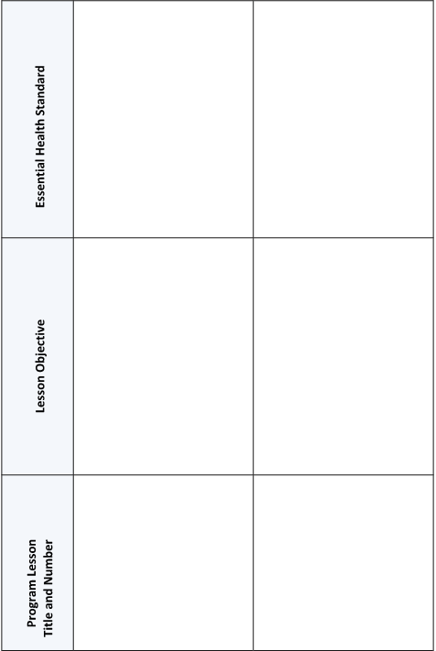
Standards Alignment Chart SAMPLE

Develop and Foster Collaboration
Benefits of Collaboration
•
Partnerships add value by drawing on the expertise of a variety
of people who know an issue from different perspectives.
•
Schools (and some community organizations) provide access
to all students in a community (including underserved
populations) and are geographically central and familiar to
community residents.
•
Schools (and some community organizations) are often seen as
positive and neutral environments. Partnering with these types
of organizations can increase visibility and acceptance of the
program within the community.
•
Schools or other organizations may have access to funding
channels to assist with the cost of the program. School or
organization staff might be utilized as additional resources to
help implement the program or increase parental participation.
•
Having multiple stakeholders increases the likelihood that
projects will be accepted and sustained over the long haul.
•
Partnering with one or more organizations multiplies the
group’s creativity since a wider variety of solutions can be
generated.

Develop and Foster Collaboration [continued]
- School/agency/staff members are already overworked.

- Time constraints for schools/agencies due to implementation of multiple programs/initiatives.

- Increased focus on testing and academic performance at schools.

- Singular perspectives: each school or agency is focused on their own mission and prevention may not be a priority.

- Differing mandates and procedures leading to lack of understanding of constraints.

- Some schools/agencies do not perceive prevention programs as effective.

- Terrible T’s: Tradition, Turf, Trust, Time and Trouble (feeling it is too much trouble to overcome barriers and take a collaborative approach).
Barriers to Collaboration
Other Barriers:
Purpose:
Work with a team assigned by the facilitator to develop a short presentation to the whole
group about one element of effective collaboration.
Activity: Elements of
Effective Collaboration
Instructions:
- Review your assigned element of effective collaboration.
- Establish trust
- Communicate well and often
- Be responsible
- Discuss challenge and problems respectfully
- Take interest in your partner

- Prepare a presentation (no more than 2 minutes) for the class.
- Explain the element of effective collaboration and
- Provide tips for facilitators to apply the element to their work.

- Be creative with your presentation. Use your group’s collective knowledge and experience to enhance the content provided.

Elements of Effective Collaboration
implement the strategy he/
and
Establish trust
Demonstrate that you are committed to the program and that you
will follow through on all your promises. Be known as a valued
representative of your organization who is invested in this project.
Demonstrate respect by valuing others’ differences, judgment, time
and expertise; compromise when necessary.
•
If you are unsure of how to handle an issue in the classroom,
ask the classroom teacher to share his/her expertise about
how to handle the situation
she suggests.
•
Schedule meetings and trainings at convenient times
and locations to show that you understand the school/
organization’s constraints and demands for time.
•
Gain approval from the school/partner organization before
you share/publicize any information about the program.
•
Even if you are working with a school district or a number of
schools, develop a working relationship with each individual
school you have a partnership with.

•
Be aware of the unique time constraints of schools and
teachers. Planning within a school often occurs up to one
year in advance and isn’t likely to be adjusted easily. Teachers
spend most of their day with students and have little time
for communicating with organizations and developing new
programs. Even when teachers can use outside assistance, you
may need to be patient in order to establish the relationship.

Elements of Effective Collaboration

[Continued]

Communicate well and often
Discuss effective means of communicating with your project partners (regularly scheduled meetings, written updates, teleconferences etc.), and then do it often. Establish methods for solving problems, reaching agreements and resolving conflict. Clarify the roles and responsibilities of all partners and put it in writing. Assign note taking responsibilities for each of your meetings and then distribute the notes to all partners. Keep your partners informed about all project developments. Hold an annual meeting to discuss strengths, weaknesses and opportunities.
- Identify the specific people you will work with. Get to know them and their work style. Keep the principal informed, even if your main contact is someone else within the school.
- Find out how your contacts prefer to communicate (email, phone, written notes etc.). Ask each teacher you work with when he/she has planning or “prep” time. Find out how to reach your contacts during breaks, if necessary.
- Be aware of the school calendar, when the quarters and semesters end, when staff development days are scheduled, etc. You will want to avoid those peak times when deciding a time to contact the school.
- Make program planning and implementation decisions jointly to ensure that both partner’s needs/concerns are addressed.
- Identify and use an agreed upon method of keeping the school/organization informed of progress and changes in the program (e.g., weekly email updates; monthly meetings etc.).
- Organize “lunch & learns” or similar formats with partners to discuss the program and share resources.
- Share and review any process or outcome evaluation data you collect related to the program with the other partner(s) in the collaboration.
- Develop a schedule for revisiting goals and objectives and reviewing the linkage agreement, annually at a minimum.

Elements of Effective Collaboration

[Continued]

Be responsible
Act professional at all times; never do/say something inappropriate that might offend the other person. Complete all your assignments by the date you promised. If there are delays, tell your partners and give them a reasonable date to expect completion of the tasks.
- Follow the school/organization’s rules and regulations in regard to dress, professional conduct etc.
- Arrive to program sessions and meetings on time; contact the appropriate person(s) if you will be unavoidably late or unable to attend. Schedule at least one make-up day in advance in case of unexpected cancellations.
- Follow through promptly on any commitment you make (e.g. complete paperwork, provide information, respond to requests etc.).

Discuss challenges and problems respectfully
Any challenges or problems need to be discussed openly and respectfully. At any point in the collaboration, one partner may be experiencing difficulties and it is important that they feel able to share their concerns or situation with the partners without fear of consequence. It is the task of the collaborators to work together toward solving these challenges.
- Share concerns with the appropriate person. For example, if you have challenges in the classroom, first address those challenges with the classroom teacher. If you experience problems with program logistics, address those with an administrator or program contact.
- Share concerns in a professional manner. For example, schedule a time that is convenient for everyone involved and share concerns in way that demonstrates your understanding of your partner’s needs or constraints. Present concerns in the context of the program and best practice.
- Listen thoughtfully to program partner’s concerns and work with them to identify a solution that meets the needs of everyone involved.

Elements of Effective Collaboration

[Continued]

Take interest in your partner
Take time to get to know your partners (administrators, teachers, line staff, assistants etc.) on a professional and personal level. Consider ways that you may support their work in other ways (serve on a school committee, volunteer at an open house, etc.) Be interested in hearing about their vacation, their child’s graduation, a family illness, etc.
- Invest time in getting to know the contacts with whom you work most closely (principal, dean, teacher, executive director, administrative assistant etc.). Show a personal interest in the other person.
- Go out of your way to help the contacts you have (i.e. volunteer for events unrelated to the program, help clean the space you utilize etc.)
- Attend partner school/organization meetings to gain an understanding of the issues they are facing and to show interest.
- Acknowledge people with eye contact and a friendly greeting when you see them in the school/organization or community.
- Understand the school environment and needs. Be knowledgeable about test scores, demographic data, truancy rates, etc.
- Remember that educators must always ask: “How will this help students?” Understand and be able to articulate the goals and teaching strategies of your program to teachers. Know what level of involvement will be required of them.
- Develop a working knowledge of the school’s programming priorities and the school’s curriculum. Know the school’s policies that relate to you. Become familiar with the mandates (No Child Left Behind, Safe and Drug Free Schools, etc.) that apply to your school.

Elements of Effective Collaboration [continued]

Take interest in your partner (continued)
- Try to determine if other community organizations have partnerships with the school or school district. It might be helpful to meet with individuals from that organization to talk about their program, what has worked well in their school partnership and the lessons they’ve learned.
- Bring in treats (coffee, bagels, cake, cookies etc.) for staff members when you go to a meeting/program at your partner school/organization.
- Send thank you notes when appropriate.
- Opt for in-person contact over phone or email whenever feasible.

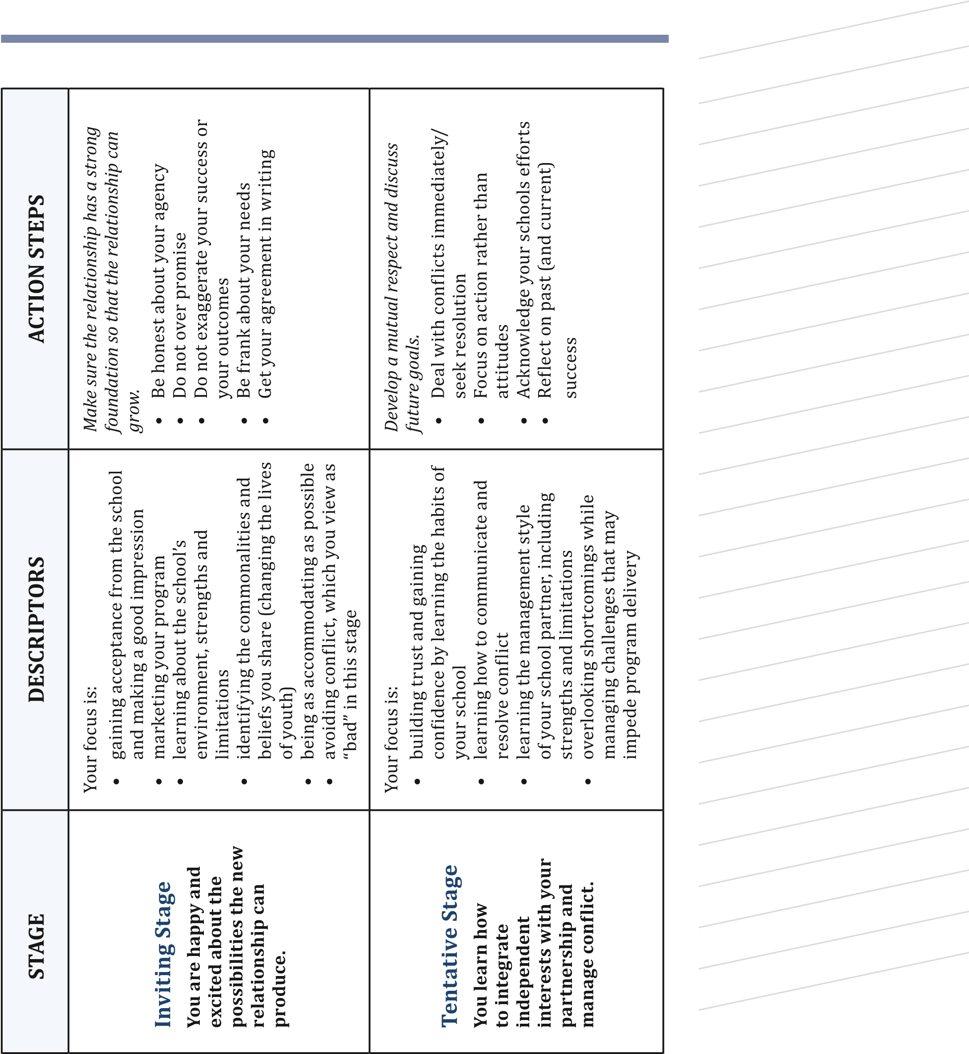

Stages of Relationship Building
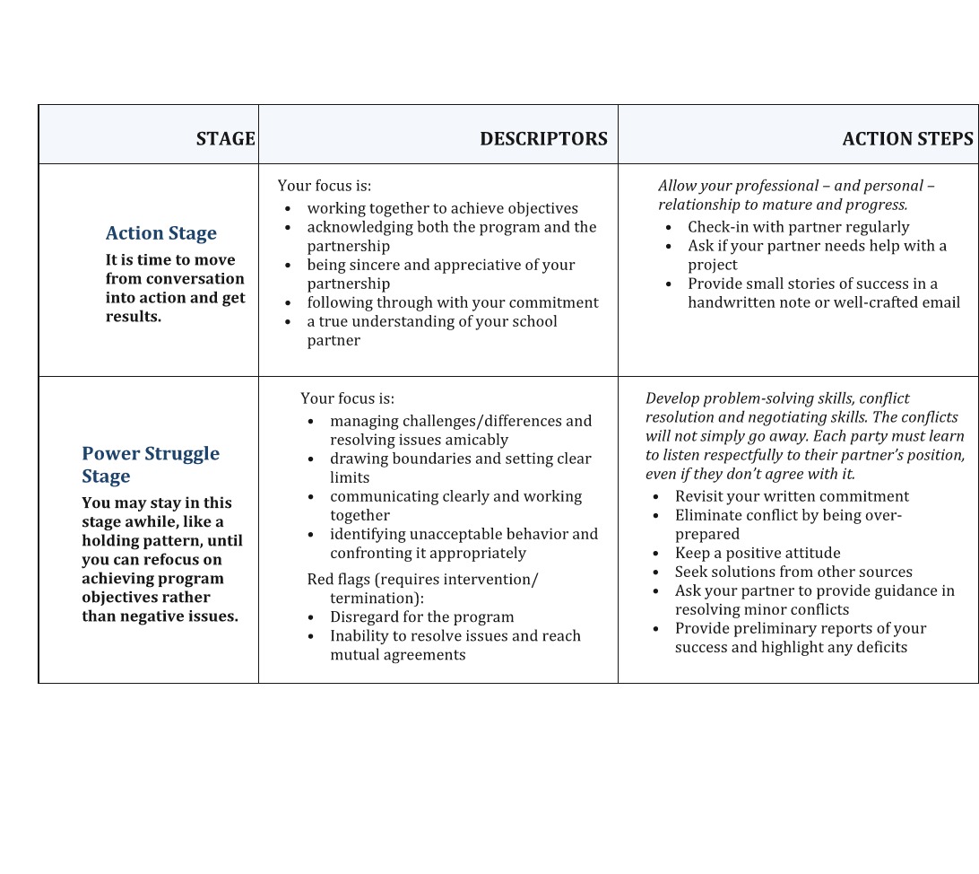

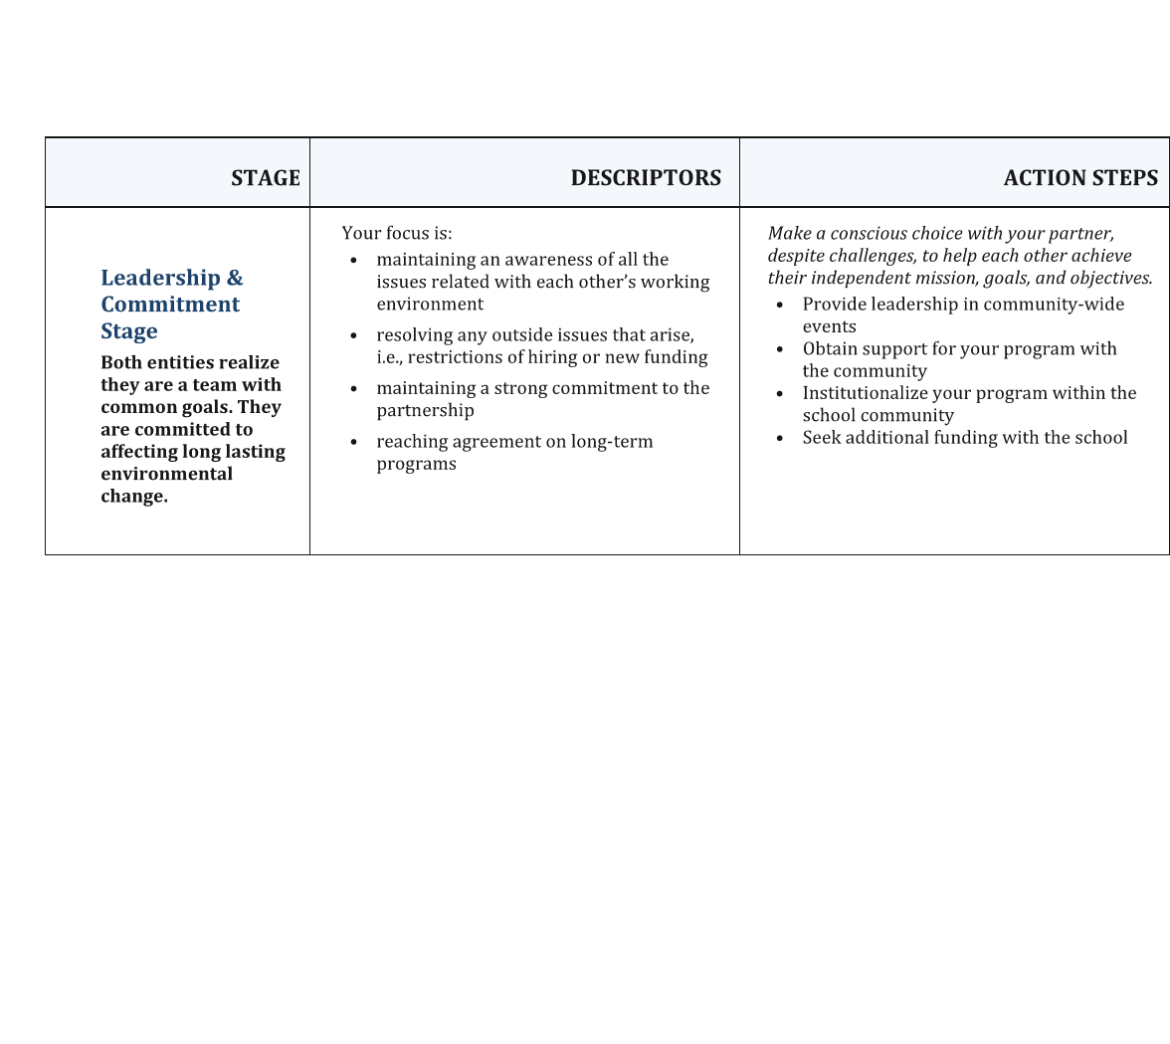
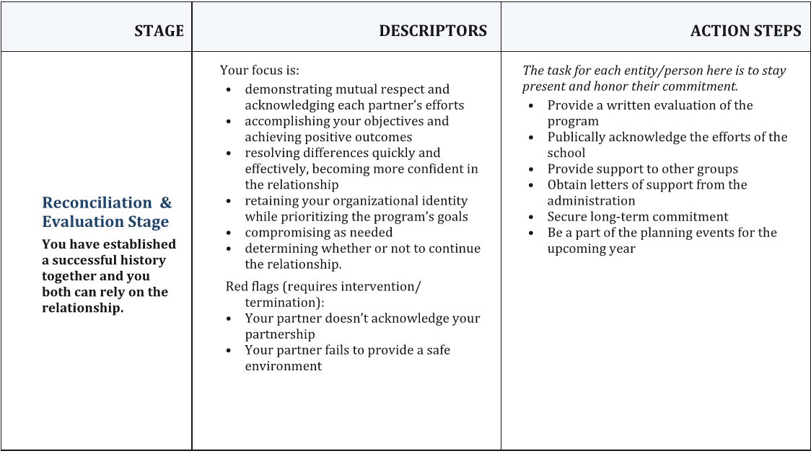

Implementation Criteria for YPE Curricula

***Reference the ATOD Prevention Guide***

STAFF PREPARATION
Demonstrate that each staff member assigned to the program activity completes appropriate training for the curriculum being implemented. Providers who are implementing Youth Prevention Education programs have the opportunity to select from the list of pre-approved evidence-based programs. If programs will be used that are not on the pre-approved list- they must adhere to the standards, and be approved by the Division.

CORE CURRICULUM IMPLEMENTATION: PROGRAM SETTING
Demonstrate that the core curriculum was implemented in an appropriate setting. When using an evidence-based program, the curriculum should be implemented in a setting recommended by the program developer.

CORE CURRICULUM IMPLEMENTATION: AGE APPROPRIATENESS
Demonstrate that the core curriculum is age appropriate for all core curriculum participants. When using an evidence-based program, the age of the program participants should adhere to the recommendations of the program developer.

CORE CURRICULUM IMPLEMENTATION: NUMBER OF SESSIONS OFFERED
Demonstrate that the prescribed number of core curriculum sessions is being offered to the majority (80%) of core program participants. All required sessions of the core curriculum are implemented. Optional sessions created by the program developer may be added to implementation of the required sessions.

CORE CURRICULUM IMPLEMENTATION: SESSION FREQUENCY
Demonstrate that the core curriculum is offered no more than
twice per week for the majority (80%) of the core program participants, as stated in the Program Standards for Youth Prevention Education Curricula.

CORE CURRICULUM IMPLEMENTATION: SESSION LENGTH
Demonstrate that core curriculum sessions are offered at the prescribed length for the majority (80%) of core program participants. Sessions cannot be less than 30 minutes long, in keeping with the Program Standards for Youth Prevention Education Curricula (regardless of program developer recommendations).
BOOSTER CURRICULUM IMPLEMENTATION:
If there are Booster Sessions to complement the Core Curriculum, it is mandatory that you implement them as well with model fidelity. Example: All Stars Curriculum has 13(Core) Mandatory Sessions and 9 (Booster) Sessions

BOOSTER CURRICULUM IMPLEMENTATION:

PROGRAM SETTING
Demonstrate that the booster curriculum was implemented in an appropriate setting. When using an evidence-based program, the curriculum should be implemented in a setting recommended by the program developer.

BOOSTER CURRICULUM IMPLEMENTATION: AGE APPROPRIATENESS
Demonstrate that the booster curriculum is age appropriate for all booster program participants. When using an evidence-based program, the age of the program participants should adhere to the recommendations of the program developer.

BOOSTER CURRICULUM IMPLEMENTATION: NUMBER OF SESSIONS OFFERED
Demonstrate that the prescribed number of booster curriculum sessions is being offered to the majority (80%) of booster program participants.
All required sessions of the booster curriculum are implemented. Optional sessions created by the program developer may be added to implementation of the required sessions.

BOOSTER CURRICULUM IMPLEMENTATION: SESSION FREQUENCY
Demonstrate that the booster curriculum is offered no more
than twice per week for the majority (80%) of booster program participants, as stated in the Program Standards for Youth Prevention Education Curricula.

Negotiate a Strong Agreement
A linkage agreement or letter of commitment can document the agreement between two parties (usually a school and community-based agency) to implement a YPE program. The letter should be written on the school or agency’s letterhead and signed by each organization’s executive staff/administrator/official. The agreement should identify shared expectations for the program and establish a plan to implement the program according to best practice. At minimum, it must include the following content:
- The school’s/agency’s commitment to support the delivery of the curriculum, including both core and “booster” sessions
- Name of the curriculum
- Grade level(s) targeted for the core sessions
- The number of sessions in the core curriculum
- The length of the session, in minutes
- The number of classes, by grade level
The agreement should be reviewed and reaffirmed each year and any time there is a change in school or agency leadership.

Identify Shared Expectations
When partnerships are based on a common goal, shared responsibilities and shared rewards, the partners are more likely to be fully invested in the goal and demonstrate an ongoing commitment to achieving outcomes.
At the start of the program partners should agree on:
- a common goal for the program,
- the roles and responsibilities of each partner,
- the tangible and intangible resources (expertise, funding, supplies, manpower, space etc.) each party will contribute, and
- the benefit(s) each party stands to gain from the partnership.
Thus, partners make joint decisions based on what’s best for the program and control/power is distributed equally. Each organization believes in the partnership and it is supported from top to bottom. While the benefits to each party may be different, everyone involved shares equal benefits and respects each other’s investment.

Adhere to Best Practice
When negotiating the program agreement with the school, it is important to make sure the plan/schedule for implementing the program meets all of the evidence-based program guidelines for implementation or all of the YPE standards. Providers implementing YPE are required to meet all of the implementation criteria for YPE curricula.
It is critical to foster a partnership with a school that is fully invested in implementing the program with fidelity. The school must also be willing to dedicate the resources necessary to implement the program effectively. This includes insuring that all students of the identified grade level receive the program in a classroom setting conducive to learning.
Evidence-based programs have been developed and tested with a specific audience, in a specific setting with a clearly defined implementation plan. If the program is not implemented with fidelity, as designed and tested, then you cannot expect the program to demonstrate results. Furthermore, the YPE implementation criteria are based on prevention best practice and research. If each criterion is not met, you cannot expect the program to demonstrate results.
* If during the planning stages of the program you are facing multiple roadblocks in ensuring all criteria are met, then the school may not be ready to implement the program. You may need to provide further education on best practice, or consider halting/delaying the program at the school until the program can be implemented with fidelity.

MOU/MOA CHECKLIST
When creating a linkage agreement between your agency and the school/Community based agency in which a YPE curriculum
is to be delivered, it is important to consider and make clear, the responsibilities of both parties. A comprehensive linkage agreement can help to solidify a partnership, avoid or mitigate conflict and detail the current and future components (e.g. core and booster sessions) needed for success. This checklist will help ensure all
necessary information in the linkage agreement is accounted for.

Agreement Overview
- Date the agreement was established
- Description of services/program goals and objectives
- Names of all parties involved

Scheduling
- Start and end date of the curriculum (core and booster)
- Grade level(s) to receive the core and booster curriculum
- The class period, timeframe, teacher and room number in which
the program will be delivered (e.g. Period 4, 10:04 – 10:49, Ms.
Smith, Room 305)
- Date of each lesson number (Lesson 1: Respect - 10/11/07 etc.)
[Review the school calendar with the school and account for any
holidays, field trips, assemblies etc. that may disrupt scheduling]
- Dates of make-up sessions in anticipation of session
cancellations due to unforeseen circumstances such as a snow day,
fire drill, assembly, staff illness, etc.
[schedule at least one make-up day]
- Additional sessions (e.g. an orientation session to get to know
students; an evaluation session(s) to administer reaction surveys,
pre-/post-tests etc.)
- Programming beyond normal school hours. (e.g. family night,
‘graduation’/completion ceremony etc.)

MOU/MOA CHECKLIST [continued]

Roles and Responsibilities of Agency
Include the agreed upon roles and responsibilities of the agency, which may include and is not limited to:
- Number of staff members to facilitate of the program
- Provision of curriculum guides and participant materials
- Procedure for cancelling a session due to unforeseen circumstances
- Procedure for communicating with teachers and principals regularly
- Provision of program data (anecdotal, survey results, pre-/post-test data)
- Provision of program incentives/rewards

Roles and Responsibilities of School
Include the agreed upon roles and responsibilities of the school, which may include and is not limited to:
- Certified teachers to remain in the classroom during each session
- Provision of location for program implementation
- Procedure for cancelling a session due to unforeseen circumstances
- Procedure for rescheduling cancelled sessions
- Participation in program evaluation (teacher feedback, class
time to administer program evaluation, class time to administer surveys)
- Provision of necessary AV/equipment
NOTE: Be sure to account for all of the tasks each partner is responsible for completing and the tangible and in-kind resources each partner will contribute to the program.

MOU/MOA SAMPLE

XYZ Agency and ABC School
7/1/2018 – 6/30/2019

In partnership, XYZ Agency and ABC School will collaborate to implement Project ALERT in ABC School. Project ALERT is an evidence-based program for middle school students. The goals of the program are to: prevent adolescents from beginning to use drugs, prevent those who have already experimented from becoming regular users and prevent or curb risk factors that have been demonstrated to predict drug use.
Eleven core lessons will be taught in 6th grade with three additional booster lessons in 7th grade. The core program will be implemented during Health classes. In order to reach all students, three classrooms will be taught per week with lessons once a week for 11 consecutive weeks.

Core Program Schedule:
6th Grade | CYCLE 1 | CYCLE 2 | CYCLE 3
 | Tuesdays  9:20 – 10:10  Ms. Shaw, R 201 | Wednesdays  10:16 – 11:06  Ms. Shaw, R 201 | Thursdays  12:44 – 1:34  Mr. Jones, R 105
Orientation | 9/20/18 | 9/21/18 | 9/22/18
Lesson 1 | 9/27/18 | 9/28/18 | 9/29/18
Lesson 2 | 10/4/18 | 10/5/18 | 10/6/18
Lesson 3 | 10/18/18 | 10/19/18 | 10/20/18
Lesson 4 | 10/25/18 | 10/26/18 | 10/27/18
Lesson 5 | 11/1/18 | 11/2/18 | 11/3/18
Lesson 6 | 11/8/18 | 11/9/18 | 11/10/18
Lesson 7 | 11/15/18 | 11/16/18 | 11/17/18
Lesson 8 | 11/29/18 | 11/30/18 | 12/1/18
Lesson 9 | 12/6/18 | 12/7/18 | 12/8/18
Lesson 10 | 12/13/18 | 12/14/18 | 12/15/18
Lesson 11 | 1/4/19 | 1/5/19 | 1/6/19
Evaluation | 1/11/19 | 1/12/19 | 1/13/19
Make-Up Days | 1/18/19  1/25/19 | 1/19/19  1/26/19 | 1/20/19 1/27/19
MOA/MOU SAMPLE [continued]
Booster Program Schedule:
7th Grade | CYCLE 1 | CYCLE 2 | CYCLE 3
 | Tuesdays  10:16 – 11:06  Ms. Hote, R 312 | Wednesdays  8:21 – 9:14  Mr. Jones, R 105 | Thursdays  1:40 – 2:30  Ms. Hote, R 312
Orientation | 10/9/18 | 10/10/18 | 10/11/18
Lesson 1 | 10/16/18 | 10/17/18 | 10/18/18
Lesson 2 | 10/23/18 | 10/24/18 | 10/25/18
Lesson 3 | 10/30/18 | 10/31/18 | 11/1/18
Evaluation | 11/6/18 | 11/7/18 | 11/8/18
Make-Up Days | 11/13/18 | 11/14/18 | 11/15/18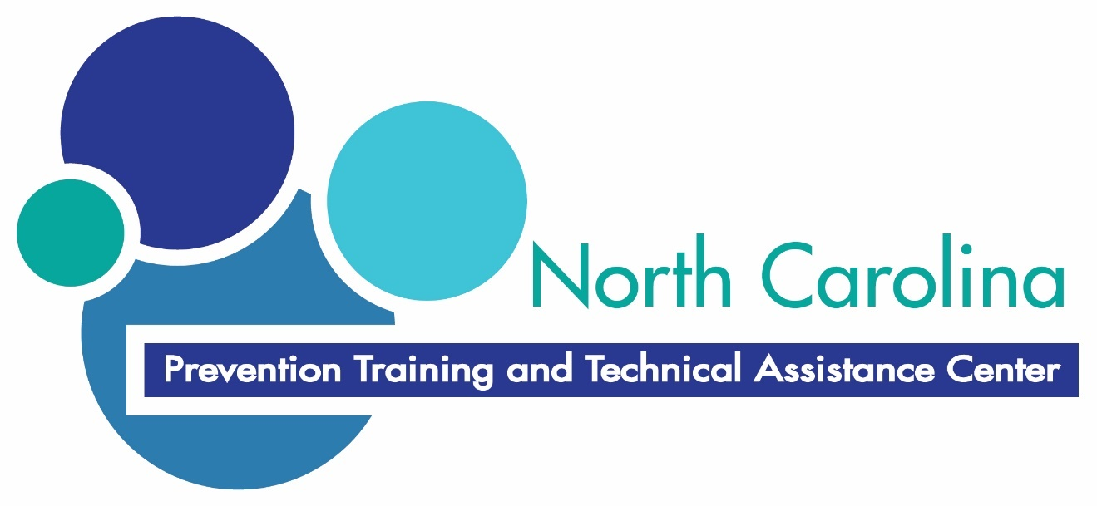

XYZ Agency will:
- Provide two trained facilitators to implement the program and supply materials.
- Contact the Principal to cancel a session in an emergency. At least 24 hours advance notice will be provided whenever possible.
- Provide a monthly report to the Principal regarding program implementation.
- Attend a minimum of two planning meetings per year with all program staff.
- Provide evaluation data collected from program participants to the Principal.
ABC School will:
- Contact the Agency Director to cancel a session in an emergency. At least 24 hours notice will be provided whenever possible.
- Provide a TV and DVD player for each program session.
- Attend a minimum of two planning meetings per year with all program staff.
- Provide adequate classroom space and ensure a classroom teacher is present at all times during program implementation.
- Send a letter to parents of 6th graders introducing them to the program.
- Provide class time for program evaluation (including observation, outcome and process evaluation if necessary).

Include signatures of school and agency representatives.

Purpose:
Work with your group members to identify problems related to
implementing a YPE program using a scenario assigned to you by the facilitator and and
prepare and present a skit that demonstrates the issues and your
response.
Instructions:
1
. Read your scenario.
2
. Use the worksheet on the following page to list the key issue(s)
to be addressed. Identify those concerns that will prevent the
agency from implementing the program successfully and/or
meeting the implementation criteria for YPE.
3
. Using the setting provided in the scenario, create a skit that
demonstrates all the key issues within your scenario and
include how you would respond/address them. Be creative and
use the resources provided earlier in the training.
4
. You will have 5 minutes to present your skit.
Activity: Scenarios

Scenarios Planning Worksheet
Key Issues | Response

Scenario #1

Curriculum Being Utilized: Botvin’s Life Skills Training (Middle School)

Population Type: Universal

Target Grade Range: 6th – 9th

Number of Sessions: Y1 – 15 mandatory/3 optional

Y2 – 10 mandatory/2 optional

Y3 – 5 mandatory/4 optional

Grades Receiving Program: 5th – 7th

Years in Partnership: 3 years

Number of Agency Staff: 1 staff

There is a new principal at your partner school who doesn’t seem very supportive of prevention. Despite the fact that your agency has been providing services for the past three years, and is in the middle of implementing the program, the new principal isn’t sure that the program should continue based on some concerns raised by school personnel. The once supportive, parent advisory council leader has recently seen information that indicates the program is not intended for 5th graders and thinks the 5th - 7th graders should no longer receive the program. She thinks it should only be implemented with 8th graders. She wants the 8th graders to receive the first 15 sessions of the program because she recently heard that eighth graders were drinking at a party in her neighborhood. You have a meeting scheduled with the principal and the parent advisory council leader to discuss whether/how the program will continue.

Scenario 1 Key Issues:

1. There is a new principal at your partner school who doesn’t seem very supportive of prevention and isn’t sure that the program should continue.

2. The parent advisory council leader thinks the program isn’t appropriate for fifth, sixth and seventh graders and should only be implemented with eighth graders.

CORE CURRICULUM IMPLEMENTATION: AGE APPROPRIATENESS

Demonstrate that the core curriculum is age appropriate for all core curriculum participants. When using an evidence-based program, the age of the program participants should adhere to the recommendations of the program developer.

PLANNING FOR ALL CURRICULUM LEVELS

Demonstrate that program participants are scheduled to receive all levels of the selected curriculum, core and boosters.

Scenario #2
Curriculum Being Utilized: Too Good for Drugs
Population Type: Universal
Target Grade Range: 5th – 8th
Number of Sessions: 10 sessions per grade level; at least 2 consecutive grade levels must be targeted
Grades Receiving Program: 6th – 7th
Years in Partnership: 5 years
Number of Agency Staff: 3 staff

The social worker has walked by the classroom while you were implementing a session that was lecture-based where students seemed very disengaged/otherwise occupied. He has since questioned your qualifications to implement the program. The principal has requested a meeting with you and your director to discuss the social workers concerns. Also during this meeting, the principal asks you to deliver the core program to the fifth grade classes and the booster sessions to the sixth grade classes. The principal is concerned because the fifth grade is not receiving any type of prevention services, and the seventh graders participate in two other non-academic community programs. During the meeting, you find out that another agency has been implementing a different ATOD prevention program to seventh graders for the past several years. You delivered the core training to last year’s sixth grade class and thus the seventh graders need the second year of the program. You had intended to deliver the core program to the new sixth graders and boosters to the seventh grade classrooms, as you have done in years past.

Scenario 2 Key Issues:

1. The school social worker has questioned your qualifications.

STAFF PREPARATION
Demonstrate that each CGP staff member assigned to the program activity completes appropriate training for the evidence-based or standards-based curriculum being implemented.

Scenario #3

Curriculum Being Utilized: Project ALERT
Population Type: Universal/Selected
Target Grade Range: 7th – 8th
Number of Sessions: Y1 – 11 sessions
Y2 – 3 sessions
Grades Receiving Program: 7th and 8th
Years in Partnership: 2 years
Number of Agency Staff: 2 staff

Your partner school has received awards for its’ comprehensive curriculum and student test scores that exceed state averages. Ms. Ina Fective is the curriculum coordinator at your partner school. She is not pleased that she has to incorporate your program into the curriculum schedule. She would like for you to offer all the core sessions over a three week period in Fall and then implement the booster sessions over a one week period in Spring. You have told her that this would make the program ineffective, but she doesn’t seem to understand. Ms. Ina Fective has also told the teachers that they can take breaks during your classroom time, even though you raised this issue last year and requested that the teachers remain in the classroom during the program. She simply believes you are unwilling to compromise, so she has expressed a desire to terminate the partnership with the principal. The principal has been supportive and believes that there is a need and a benefit to having your agency at the school. You have tried taking your concerns regarding the implementation of the curriculum to the principal, but he is unwilling to intervene. In addition, you recently presented IYS data to the school staff, which revealed a reduction of ATOD use in the school. During the meeting, the social worker commented that the reductions are a direct reflection of your agency’s commitment and hard work. You have a meeting scheduled with Ms. Ina Fective to discuss the program.

Scenario 3 Key Issues:

1. Ms. Ina Fective would like for you to offer all the sessions over a two week period.

CORE CURRICULUM IMPLEMENTATION: SESSION FREQUENCY
Demonstrate that the core curriculum was offered no more than twice per week for the majority of the core program participants, as stated in the SAPBG Program Standards for Youth Prevention Education Curricula.

Scenario #4

Curriculum Being Utilized: All Stars
Population Type: Universal/Selected
Target Age Range: 11 – 14
Number of Sessions: Core – 13 mandatory/8 optional
Booster – 9 mandatory/6 optional
Plus (optional) – 12 mandatory/ 5 optional
Grades Receiving Program: 6th – 8th
Years in Partnership: 6 years
Number of Agency Staff: 1 staff

Numerous new challenges have arisen with your long-time partner school. The school has not met their academic goals for the second year in a row and is on the state-wide watch list. The teachers complained to the principal that the program is a waste of time because the classes are chaotic and the students don’t pay attention. They believe the time should be spent preparing students for state testing. As a result, the principal’s assistant informed you that the program in all grades will be moved to a 20 minute homeroom period this year. The principal is extremely unresponsive and refuses to participate in any “nonessential” meetings. Due to the low morale within the school, student attendance rates have dropped, and only about 70% of the children in the program participate each week. You have a meeting scheduled with your supervisor to discuss the issues and next steps.

Scenario 4 Key Issues:

- The teachers complained to the principal that the program is a waste of time. The principal is extremely unresponsive and refuses to participate in any “nonessential” meetings.

- The program in all grades will be moved to a 20 minute homeroom period this year.

CORE/BOOSTER CURRICULUM IMPLEMENTATION: SESSION LENGTH
Demonstrate that core/booster curriculum sessions are offered at the prescribed length for the majority of core program participants. Sessions cannot be less than 30 minutes long, in keeping with the SAPBG Program Standards for Youth Prevention Education Curricula (regardless of program developer recommendations).

Scenario #5

Curriculum Being Utilized: Standards-based curriculum
Population Type: Universal
Target Grade Range: 9th – 10th
Number of Sessions: 9th – 10 sessions
10th – 5 sessions
Grades Receiving Program: 9th – 10th
Years in Partnership: 2 years
Number of Agency Staff: 1 staff

You worked closely with school health teachers and administrators to develop a prevention program for freshmen and sophomores at a local high school. The 40 minute weekly sessions were designed to 1) provide students with strategies to effectively detect and resist social pressures; 2) correct the misconception that alcohol, tobacco and other drug use is a socially normative; and 3) encompass the immediate physiological effects of substances and how their use can interfere with achieving life goals. The school has just begun a construction project which has limited the space available for students and community programs. Due to scheduling constraints related to the construction project, you are only implementing the core curriculum to half of the 9th graders this year.

Furthermore, within the first six weeks of the program, your location has moved from the library to the cafeteria and most recently the gym. Since there are not any desks in these locations, students sit on the floor and are not as attentive as they were the previous year when the program was facilitated in a classroom. They often forget to bring their workbooks, writing utensils etc. with them. Some sessions have been cancelled without any notice. You have a meeting scheduled with the principal to discuss your concerns.

