**Module Two:**

## Creating Effective Classroom Environments

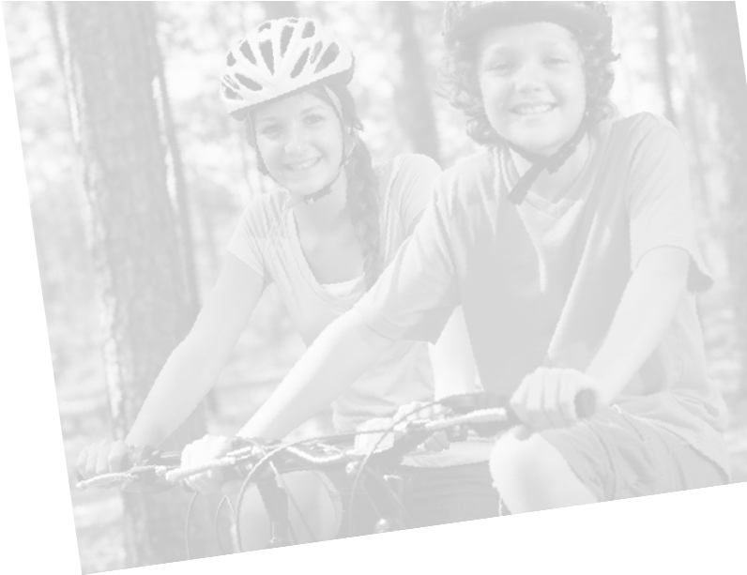



60

**Purpose:**

Work with your group members to discuss and identify how the

characteristics of adolescents in a specified stage of growth might

affect facilitation of YPE.

**Instructions:**

1

.

Review the developmental characteristics of your assigned age

group on the following page.

.

2

Discuss what else you know about the students you know or work

with who are that age.

3

.

Brainstorm the intellectual, emotional and physical needs of

students this age in the classroom, based on their developmental

characteristics (i.e. how will you address students’ developmental

needs in the classroom?). Provide as many specific examples as

possible.

4

.

Draw an outline of a child and label the picture with what the

student needs. For example:

List intellectual needs (head)

List social/emotional needs (heart)

List physical needs (body)

**Activity: Adolescent**

**Development**

### Stages of Adolescent Development

61

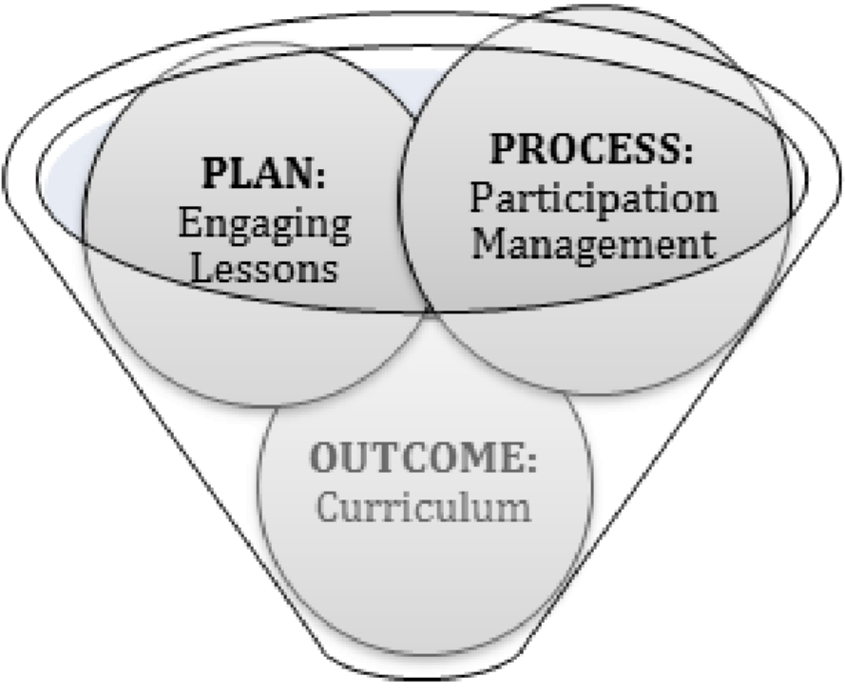

Facilitators must balance a variety of factors in order to create an

effective learning environment.



**Effective Classroom Management**

**Create an Effective**

**Classroom Environment**

### Create an Effective Classroom Environment

#### [continued]

* **Outcome:**  The goal of YPE is prevent youth ATOD use. In order to achieve that outcome, a quality curriculum (such as a approved, evidence-based curricula or a standards-based curricula) is critical. The curriculum should be implemented with fidelity to help insure the anticipated results are achieved.
* **Plan**: An effective environment is one where students are productively engaged in purposeful lessons. A facilitator holds the key to classroom management by planning engaging lessons with a balanced flow of teaching, student participation and objective focused tasks. If students are purposefully engaged throughout the lesson, behavior issues are less likely to occur.
* **Process:** Students cannot learn amid distrust or chaos. The final factor in creating an effective learning environment is managing the process of learning in the classroom. The facilitator has to be aware of and observant about group dynamics and student participation, attempting to reaffirm and trust participants’ contributions.

**Fidelity and Adaptation**

#### Fidelity

Fidelity is the degree to which a program, practice or policy is implemented according to its design. The higher the degree of fidelity, the more likely you are to achieve the success indicated by the evidence-based program.

Maintaining program fidelity is important because:

* program developers and prevention researchers are concerned that changes in science-based programs will dilute the program’s effectiveness,
* funders are demanding more program accountability, and
* loss of program fidelity and/or informally or poorly run programs may result in more harm than good (i.e. once the program has been highly modified, no one quite knows how it will operate or what unexpected consequences it will produce.

#### Adaptation

Program adaptation is the deliberate or accidental modification of the program. While some adaptations might be necessary in order to create a better fit between the program and the community, adapting any part of a program without understanding the underlying rationale might decrease the likelihood of achieving planned outcomes.

Providers are expected to implement YPE programs with a high level of fidelity. This means that programs should adhere to the developer-proscribed curriculum. Adaptations, even those that seem reasonable, must meet the implementation criteria. Consider using the implementation criteria as a checklist during program implementation to keep track of the requirements.

### Communication Skills for Facilitators

As a facilitator it is important to be able to communicate effectively

and to recognize the effects of what you are saying, and the way in

which it is being said. We communicate what we are thinking and

feeling through verbal and non-verbal cues.

**Non-Verbal Techniques**

•

Body Language

◊

Maintain an open and inviting posture

◊

Turn your body to the person speaking

◊

Nod to signify understanding

◊

Maintain eye contact with participants/speaker

◊

Demonstrate self-confidence

◊

Attend to the body language of others, and tailor your message

•

Facial Expression

◊

Smile to show enthusiasm for the topic

◊

Match your expression to the discussion/comments being made

◊

Be aware of your facial expression, don’t let it convey

judgments

•

Placement

◊

Place yourself near the speaker; move among participants

◊

If possible, arrange seating that supports the goal of the lesson

◊

Maintain an appropriate level of your own personal space

•

Tone of Voice

◊

Match your tone of voice to your facial expression and words

◊

Maintain a positive tone, even when frustrated or irritated

#### Communication Skills for Facilitators

##### [continued]

###### Verbal Techniques

• Active Listening

* Use open ended questions to clarify points and engage participants
* Paraphrase to reflect back what has been said
* Summarize participants’ comments periodically to demonstrate attentiveness
* Be non-judgmental and avoid interrupting, even when correcting information

• Language

* Use proper grammar
* Use language that is appropriate to the grade level you are teaching

### Strategies for Engaging Students

An anticipatory set is the first part of a lesson plan. It is sometimes called a “hook” because it is meant to grab students’ attention. The anticipatory set should quickly:

* Review previous material that is relevant to the lesson,
* Link prior experiences to new information,
* Focus attention,
* Create interest, and
* Preview new information.

If successful, the anticipatory set should help students get mentally or physically ready for the lesson.

**Variety**

Kids – and even adults’ – attention spans are not that long. Review your lesson plans and ensure that it involves a balance between information/lecture and student engagement. Try planning at least three activities per lesson and shift focus/energy at least every ten to twelve minutes. You can insert energizers or brainteasers to break up longer stretches of instruction.

Lesson plans should also incorporate activities for different learning styles. For example, posters, videos, charts and handouts are great for engaging visual learners. Prepare your visual aids in advance and use bright colors and images. Discussions, audio recording and teach backs are effective for auditory learners. Kinesthetic learners learn by doing (skits, sculptures, role plays, etc.). Finally, some students learn by writing, so you might incorporate or modify an activity where students can write a letter, keep a journal or use a checklist to apply what they’ve learned.

##### Energizers and Brainteasers

Energizers and brainteasers are short interruptions meant to stimulate the brain or activate the body. They are generally used as a warm up to make participants feel more comfortable, or as a break in instruction to get participants refocused and attentive. The following websites provide resources for energizers and brainteasers:

* Big Dog’s Leadership Training and Development [www.nwlink.com/~donclark/leader/icebreak.html](http://www.nwlink.com/~donclark/leader/icebreak.html)
* Games, Games, Games Galore <http://bonnernetwork.pbworks.com/f/BonCurGamesGalore.pdf>
* Activities That Teach, Tom Jackson, 1993 [www.activelearning.org](http://www.activelearning.org)

**Anticipatory Set**

### Managing Participation

#### Inclusion

As facilitators we need to continually take stock to ensure that we treat all our students fairly and involve all students equally.

Some examples are noted below:

* Write every student’s name on a Popsicle stick. During discussions, call on a student to participate by randomly selecting a Popsicle stick vs. only calling on a student with a raised hand (which often leads to calling on the same students over and over). This expectation also keeps students on their toes.
* Round robin is a way to engage all participants in a discussion. All students answer a question, one-by-one. It is best used for short answer questions and to gather opinions.
* Use student assistants/helpers to pass out handouts/materials, read aloud content, come up to the board to record information, erase the board, help you to the next classroom etc. This keeps students involved and makes them feel like an integral part of the lesson.

#### Questioning Techniques

Questions are a great way to engage students, generate recall, identify right/wrong answers, generate new ideas and provoke thought. Students develop their learning and thinking skills when exposed to the right set of questions. Utilize open-ended questions vs. closed ended (yes/no) questions and/or redirect questions to the whole class to generate lively discussion. Affirm students’ responses. Questioning techniques include:

* at the beginning of a lesson to assess what students remember from previous lessons and to set the stage for the rest of the lesson
* during a lesson to check for understanding, change of pace and generate discussion about a topic
* at the end of a lesson to summarize the content and evaluate your effectiveness

##### Stacking

When your group is in a discussion and many people have their hands raised, use the technique of stacking. Write the people’s names in order of them raising their hands so they do not have to keep their hands up and you do not have to remember who is next.

##### Managing Participation [continued]

##### Wait time

Students often need more time to think than we think. Avoid calling on the first student that raises his or her hand. Sometimes we need to wait ten or fifteen seconds before students begin to raise their hands to respond.

* One strategy is to tell the class that no one will be called on until at least eight hands are raised.
* Another strategy is to tell students to give you a “secret” single when they have a response (it can be anything they want – such as a wink, touch of the ear etc.) but they have to wait until they have eye contact with you. Once you have received a signal from most students you can call on someone to respond. This is usually a better strategy for questions with a right/wrong answer.

##### Check for understanding

It’s important to check in with students to make sure they understand the content you are delivering. These strategies can let you know whether students are paying attention, and also maintain students’ attention during presentations.

* One strategy is to give each student three index cards with traffic signals drawn on each. One with a red light which mean they have no idea what’s going on; one with a yellow light which means they could use a few examples or illustrations; and one with a green light which means they understand. To check for understanding, simply ask students to hold up one of his/her cards. A quick scan of the room will provide a cue as to what to do next.
* Students can also hold a thumb up, sideways or down to indicate their level of understanding of the lesson.
* Ask a student to repeat instructions just provided.
* Partner students and ask each of them to explain a concept to the other as if he/she just entered the room.

##### Use Signals to Get the Group’s Attention

When you are attempting to get the group’s attention (i.e. after small group work or a lively discussion) try one of the following techniques to quickly focus the attention back to you (you need to teach students the cues prior to use):

* *Clapping*: The facilitator says “If you can hear my voice clap once.” If that does not work they continue, “If you can hear my voice clap two times.” If that does not work they go onto three times. The group typically catches on after three claps.

#### Managing Participation [continued]

* *Lights Out*: Turning off the lights or flicking them on and off.
* *Silence*: The facilitator can simply stand in the front or middle of the room in silence until the group realizes what is happening.
* *Raising Your Hand*: The facilitator can raise their hand and stand in silence until everyone else follows suit.
* *Call and Response*: Brainstorm pairs of words that you can use by calling out the first half and having participants respond with the other half (i.e. when you call out “peanut butter” students respond “jelly.”)

##### Small Groups

Small group activities increase active participation by putting students into more manageable sized groups. Use fun ways to separate students into smaller groups (when needed/specified in the curriculum).

* One suggestion is to have a bowl with pieces of paper in it that have different animals on each piece of paper. The animals should all have equal representation in the bowl (i.e., if you have 5 cows, you must have 5 pigs). Each participant selects a piece of paper out of the bowl and when the facilitator says “go” everyone should then start miming their animal’s sound (e.g., cow= person saying moo). Tell them to find their fellow animal friends and this is the group they will work in for the activity.
* When students are grouped, use cooperative learning roles to keep everyone involved. The roles (i.e. facilitator, recorder, reporter, timekeeper, observer etc.) should be posted on flip chart paper in the room and explained to the students before the activity. Explain that when they are broken into small groups to perform an activity, they should use the cooperative roles.

*Sources: Smith, R. Conscious Classroom Management: Unlocking the Secrets of Great Teaching. 2004.; Bonner Curriculum, Facilitation 101 and Facilitation 202, Web access 1/5/12.*

### 10 Tips for Behavior Management

It gives students comfort when they know what to expect.

A specific routine helps focus the group process.

This is a collection of tips/ideas from persons actually working

in the classroom setting with youth. Many of these comments

were part of an online education course that offered opportunities

to share strategies for managing early adolescent groups in the

classroom.

**1**

**.**

**Observe two or more times prior to implementing**

**the program.**

•

This allows youth to see and begin to trust you and gives you

valuable information about the environment.

**2**

**.**

**Talk with the classroom teacher before and during**

**the program.**

•

Discuss his/her expectations of the class and how behavioral

problems are addressed.

•

Determine what traditions or customs the teacher already

has that can be adopted during your facilitation.

•

Consider what incentives may be used to motivate students.

•

Get input about difficulties or problems you are concerned

about or experiencing.

**3**

**.**

**Learn student’s names.**

•

This should be done very quickly!

•

This allows trust to build and shows you care enough to learn

who they are.

•

It also gives you a management tool because you can address

each youth personally.

**4**

**.**

**Establish a routine for beginning/ending each lesson.**

•

•

#### 10 Tips for Behavior Management [continued]

##### 5. Establish group rules/norms

* Group rules/norms help to get everyone on the same page as to expectations for behavior conducive to a positive learning environment.
* Learn – and potentially adopt – the existing classroom rules/ norms. If the existing rules/norms are not sufficient or applicable, create new ones.
* Involve the students in establishing the expectations when establishing group norms; add necessary expectations the students do not generate.
* Involve the students and regular classroom teaching in setting consequences for violation of expectation/norms.
* These should be posted during every lesson and is great technique to use if the group is not following one of the agreements.

##### 6. Follow through with consequences

* Do not make empty threats; have an alternative plan for disruptive youth.
* Be consistent in expectations of ALL group members.
* Be consistent with consequences; work within the school guidelines.

##### 7. Be silent

* Silence can be deafening!
* Make eye contact with students who are not behaving as desired.
* Wait silently for the desired behavior.

##### 8. Use positive reinforcement

* Acknowledges and strengthens cooperative, positive or desirable behavior the student is currently exhibiting or has already demonstrated.
* Look for the positive in all students – you can always find something to recognize.
* Describe, recognize and/or reward the specific behavior that took place.

#### 10 Tips for Behavior Management [continued]

##### 9. MBMA (Management by Walking Around)

* MBWA uses non-verbal cues to manage the classroom.
* Oftentimes, by simply standing next to a student who is not paying attention or is being disruptive, the student will stop the negative behavior.
* Eye contact can also have a similar effect.

##### 10. DESO

• The DESO model can help facilitators address challenging behaviors and cultural differences in the classroom through clear communication *(Lambert and Myers, Cultural Awareness)*.

* **D**escribe the exact behavior that is under discussion, and your interpretation of it. Be objective. Use concrete terms.
* **E**xpress your feelings about the situation. If you’re upset, just say so calmly, speaking only about the behavior and not about the person. Show respect for the other person’s point of view.
* **S**pecify the new behavior you’d prefer. Speak about alternative approaches.
* **O**utline the outcome – the positive results – that you expect to come from the new behavior. Offer positive verbal support.

### Addressing Individual Behaviors

|  |  |  |
| --- | --- | --- |
| **Type** | **Displays** | **How to Handle** |
| **Talkative** | Something to say about everything; always volunteers | * Give limited time to express viewpoint or feelings, acknowledge comments, then move on. * Make eye contact with another participant and move toward that person. * Say, “That’s an interesting point. Now let’s see what other people think.” |
| **Rambling** | Goes on and on about nothing; uses stories, examples and analogies that do not relate | * Refocus attention by relating relevant point. * Direct questions to group that is back on subject. * Ask participant to summarize main point in one sentence. |
| **Silent** | Seems attentive but will not volunteer or answer questions; shyness | * Provide opportunities for written contributions. * Give strong positive reinforcement for any contribution. * Involve directly by asking him/her a question. |
| **Class Clown** | Can cause disruption if s/he gets out of control | • Say: “We all enjoy a good laugh. But right now, let’s get serious and concentrate on the topic at hand.” |
| **Side**  **Conversations** | Two or more members engage in own conversation | * Casually move toward those talking. * Make eye contact with them. * As a last resort, stop and wait. |

*Sources: Karen Lawson, The Trainer’s Handbook, pp. 168-171; California Nurses*

*Association, AIDS Train the Trainer Program for Health Care Providers (1988)*