Evaluating, Monitoring & Reporting YPE
Module Three:
Evaluate the Program
Process Evaluation
Process evaluation tells you about how the program was
implemented. Process evaluation is used to improve or refine
programs, identify concerns and document the program. Examples
of process evaluation tools include:
•
A Facilitator Log
is used by facilitators to keep track of
information related to participants such as attendance,
assignment completion and assessments related to each
lesson.
•
A Fidelity Checklist
is used by facilitators to keep track
of the program components they have – and have not –
implemented. Monitoring implementation is critical to ensure
that the program or practice continues to be implemented as
designed.
•
Observations
of facilitators during implementation are
conducted by an objective observer to assess fidelity and the
quality of implementation. The observation should provide
a method for feedback and a plan for addressing off-target
implementation.
•
Participant Satisfaction Surveys
collect data from
participants to obtain their reaction about the program.
This data can help improve facilitation or identify necessary
adaptations.
•
Stakeholder Interviews/Surveys
obtain feedback from
school or other organization partners about the program.
It’s important to learn the successes and challenges of the
program from their perspective.

Evaluate the Program [continued]

Outcome Evaluation
Outcome evaluation tells you whether or not the program was effective in meeting stated objectives/outcomes in your setting/ community.
Examples of outcome evaluation tools include:
- Pre/Post-Tests are implemented with participants prior to and after the program to help determine whether the program goals/ objectives have been met with your audience.
- Surveys, such as the Youth Risk Behavior Survey, can also provide information about whether risk factors and use rates are changing. While these results do not provide an evaluation of the program per se, if conducted regularly, they provide insight into the environment and trends in use.

Evaluation Tools: Examples

Fidelity Assessment SAMPLE
This fidelity assessment can be used by the facilitator or an observer to evaluate fidelity of a single lesson of a standards-based program or evidence-based program (if one is not available from the program developer).
Model Program: ________________________________________________________
Lesson: ________________________________________________________
Facilitator: ________________________________________________________
Date/Location: ________________________________________________________
List each lesson objective (indicated by the program developer): |  |  |  | Was this objective covered/met?  Yes No
1.
2.
3.
4.
5.
For each objective that was not met, indicate the reasons why not:
 | List each lesson topic and activity  (indicated by the program developer): |  |  | Was this objective covered/met?  Yes No
 | 1.
 | 2.
 | 3.
 | 4.
 | 5.
 | For each topic/activity that was not covered, indicate the reasons why not:
 | How did the lesson that was delivered deviate from the Teacher Manual? Were the modifications that were made deliberate or unplanned?
 |  | Lecture | Discussion |  | Demonstration |  | Practice
Estimate the percentage of time spent using each of the teaching techniques. (Total should equal
100%)
Were the teaching techniques consistent with the instructions? If not, why not?

 | Describe the facilitator’s strengths and areas for improvement related to teaching techniques and delivery method (consider verbal and non-verbal communication)?
 | How much time was devoted to teaching this lesson?
 | How did the time actually spent on the lesson compare to the suggested time by the developer?
 |  | 1 | 2 | 3 | 4 |  | 5
Rate on a scale from 1 (low) to 5 (high) how well students responded to this lesson.
 | What suggestions do you have for improving the delivery of this lesson?

Participant Satisfaction Survey SAMPLE
SAPST Training Satisfaction Survey
This survey has statements regarding how you feel about the training. We need you to carefully read as you go through the statements. It is important that you respond to each statement. This is an anonymous survey. Please do not write your name on this survey, unless you are requesting additional training or technical assistance.
Check the response that best represents the way you feel. | 1  Strongly disagree | 2  Disagree | 3  Agree | 4  Strongly agree
- The presentation started and ended on time.
- The setting was comfortable.
- The presenter was knowledgeable and professional.
- The presenter was sensitive to my cultural/ethnic background.
- I benefited from the material that was presented.
- The presentation was valuable to me.
- I intend to apply what I have learned today to my professional life.
- My professional capabilities, skills, or knowledge have been enhanced as a result of the presentation.
- As a result of this training, I am better able to use theory and research to guide prevention efforts.
- As a result of this training, I am better able to use a strategic planning framework to guide prevention efforts.
- As a result of this training, I am better prepared to identify specific strategies to build capacity through readiness and resources.
- As a result of this training, I am better able to conduct a formal assessment of needs within a focus population.
- As a result of this training, I am better able to select appropriate strategies to address prioritized needs.
- As a result of this training, I am better able to utilize evaluation results to refine prevention efforts.
- As a result of this training, I am better able to implement effective prevention strategies.
- As a result of this training, I am better able to implement culturally competent prevention practices.
- As a result of this training, I am better able to mobilize and engage all sectors of a defined community in implementing selected strategies.

Stakeholder Interview/Survey SAMPLE
Prevention Parent Satisfaction Questionnaire
After School Reconnecting Youth Second Step Early Risers

School: ____________________________ Group: __________________________

Part of the requirements for the funding for this program is to survey parents regarding your child’s participation in the program. When answering the questions in this brief survey please reflect on changes you have seen since the start of the program until now. Please do not base answer based just on the past few days. We appreciate you taking the time to complete the survey. Please return with your child to ________________________ at your child’s school. Thank you.
Please use the following scale listed below to indicate how much you agree or disagree with each of the following statements about the Insight program.

Strongly  Agree |  | Agree | Don’t know | Disagree |  |  | Strongly  Disagree
3. | I have seen improvement in my child’s self- esteem.
4. | I have seen improvement in my child’s ability to handle anger.
5. | I have seen improvement in my child’s attitude toward school
6. | I had at least one contact with staff regarding my child in the program. (Contact could be verbal or written.)
7. | My child enjoyed the program.
8. | My child benefited from the lessons and sills taught during the program.

Please write a brief answer to the questions/statements below. Please use the back if necessary.
9. In your opinion, what part of the ______________ program had the greatest impact on your child? (Ex. Lessons taught; staff member; extra time to learn and practice skills taught.)

- Please describe successes your child has had that you attribute to participating in the ________ program.

- Please list any suggestions you have on how to increase the quality of service or the quality of the program offered by ________________.

Pre/Post Test SAMPLE
Refer to the pre/post test for the North Carolina Youth Prevention Education Training in the Post Training section of the training.

Purpose:
To understand the kinds of data you might collect through an
evaluation plan.

Instructions:
1
.
Open your envelope and remove contents.
2
.
Assign each question in your envelope to the evaluation tool on
which it would be found:
a. Fidelity checklist
b. Participant satisfaction survey
c. Stakeholder feedback
d. Pre-/post-test
3
.
Work quickly to be the first team to match all questions
correctly. Follow instructions from your facilitator regarding
validation of answers.
Activity: Evaluation
Matching

Program Reporting

Substance Abuse Prevention activities funded through the Substance Abuse Prevention and Treatment Block Grant are reported on using the Local Management Entity-Managed Care Organization (LME-MCO) Semi-Annual Compliance Report. This section provides an overview of this report. The report includes two files that must be fully completed.
Compliance Report Excel File
This portion of the report is divided into eight sections. Each section requires different kinds of data to be entered. Sections covered in this training are as follows:
Section I: Report of SAPTBG 20% SA Primary Prevention Set-Aside Funding, Expenditures, and Persons Served by CSAP Prevention Strategy
Part A. Set-Aside Funds Received and Expended
Part B. All Other LME-MCO SA Prevention Grant Funding Received By Source
Part C. Substance Use Prevention Recipients by Child/Adult/Primary Risk Factor
Part D. Report Of Persons Served By Age, Race, Ethnicity and Gender
Part E. Prevention Number Of Consumers Served By Prevention Strategy

Section II. LME-MCO Contracted Agencies SAPTBG Primary Prevention Strategies and Activities Checklist

Section III. Prevention Program Staff, Written Program Plan and NREPP Programs
Part A. Contract Agency Prevention Program Staff, FTEs and Counties Covered
Part B. Annual Strategic Prevention Plan (Written Program Plan)
Part C. NREPP Universal, Selective and Indicated Prevention Programs

Section IV. SAPTBG Activities For Reducing Youth Access To Tobacco Products Initiative (Synar Amendment)
Part A. LME-MCO Synar Performance Measures
Part B. Merchant Education Activities Log

Compliance Report Word File

This portion of the report is used to provide narrative information related to the data reported in the corresponding excel file. Sections covered in this training are as follows:
Section III. Prevention Program Staff and Written Program Plan

Part B. Annual Strategic Prevention Plan (Written Program Plan)
Section IV. SAPTBG Activities For Reducing Youth Access To Tobacco Products Initiative (Synar Amendment)

Section 1: Report of Funding, Expenditures, and Persons Served

Section I asks for information that reports SAPTG 20% SA Primary Prevention Set-Aside Funding, Expenditures, and Persons Served by CSAP Prevention Strategy. The purpose of this section is to meet requirements set forth by SAMHSA and to fulfill SAPTG requirements.

Part C is used for reporting of substance use prevention programs that target a priority population at risk of developing substance use. Identification of community risk factors and priority populations identified in community needs assessments should inform where efforts are implemented to address priority populations and risk factors. This section asks for a simple check mark to indicate that a recipient group is served.

Part D is used for reporting unduplicated number of persons served in prevention services by age, race, ethnicity, and gender. Information should be documented by unduplicated totals, single services, and recurring services. SAMHSA required reporting in unduplicated counts.

- Unduplicated totals are the actual number of individuals served. This should include the total number of persons served, counting them only once in either a single service or a recurring service. The unduplicated total should equal the number served in single services plus the number served in recurring services.
- Single services are the actual number of individuals exposed to a single prevention presentation.
- Recurring services are the actual number of persons served through prevention programs that occur in a series Recurring services include youth prevention education programs delivered in multiple sessions as prescribed by the program developer.

Part E is used for reporting persons served by primary prevention strategy. Numbers for children include those who are below the age of 18 when the service is delivered. Number for adults include those who are 18 or over at the time when the service is delivered.

Section II. LME-MCO Contracted Agencies SAPTBG Primary Prevention Strategies and Activities Checklist

Section II is used for reporting prevention strategies, further broken down to include reporting on which specific activities are provided within a particular prevention strategy. Many allowable activities are listed. A space is provided to include activities that occur within a strategy that are not included in the pre-defined list. Early intervention activities and services that are designed to determine if a person is in need of treatment are not allowable activities under the 20% Prevention Set-Aside.

In addition, this section of the report documents level of effort spend on each strategy. The amount of staff time allocated to each particular strategy is important to report, because some strategies are more time intensive than others.

Section III. Prevention Program Staff, Written Program Plan and NREPP Programs

Part A gathers information about who operating under the prevention set aside funds, and documents the names of staff, their title and agency, the % of a FTE each staff fulfills, and the counties where each prevention staff provides service. This section also documents prevention certification status.

Part B collects an annual strategic prevention plan, based on the Strategic Prevention Framework Process. This ensures prevention services match documented needs in the community and appropriate services are being offered. These plans are submitted by the LME-MCO for the area and include populations that will be targeted in the coming fiscal year, including those High-Risk groups identified in Section 1C, as well as evidence-based programs to be implemented as described in Section 3C. This Plan should address Consultation and Education Services (10 NCAC 27G .6900) and include activities and services in each of the six Substance Abuse Primary Prevention Strategies as described in Licensure Rule 10 NCAC 27G, Section .4200 (APSM 30-1). Other areas required in the narrative include the following:

- Assessment: A data-driven profile of population needs, resources and readiness to address problems and gaps in service delivery based.
- Capacity: Identification of those within the target area who have any capability for addressing the problem(s) identified in the assessment exercise, and mobilization of those resources.
- Planning: A logic model is created and followed to select evidence-based programs, practices and policies, and to set goals, objectives and measurable outcomes as part of a strategic plan to address the problem(s) identified by the assessment data.
- Implementation: Description of how the above sections will be implemented in accordance with evidence-based practice and standards of effectiveness for each strategy.
- Evaluation: Description of how programs, practices and policies will be evaluated to achieve outcomes.
- Cultural Competence: Description of how services and initiatives are planned and implemented in a culturally competent way.
- Sustainability: Description of how you plan to integrate the value of prevention into ongoing operations, or in community systems, and how sustainability efforts will be used to maintain program outcomes.
Part C documents which NREPP Universal, Selective and Indicated Prevention Programs have been implemented, by whom, and where. This section provides information about the total number person that were enrolled through each program, and how many completed the program. Information should be entered into this form only after the program is fully implemented, in accordance with YPE standards.

Section IV. SAPTBG Activities For Reducing Youth Access To Tobacco Products Initiative (Synar Amendment)

This section demonstrates implementation of Synar Amendment provisions directed at reducing youth access to tobacco products. A narrative is required to describe specific activities implemented.

Foundations of
Youth Prevention
Education

Activities, Puzzles,
Brainteaser:
Instructions

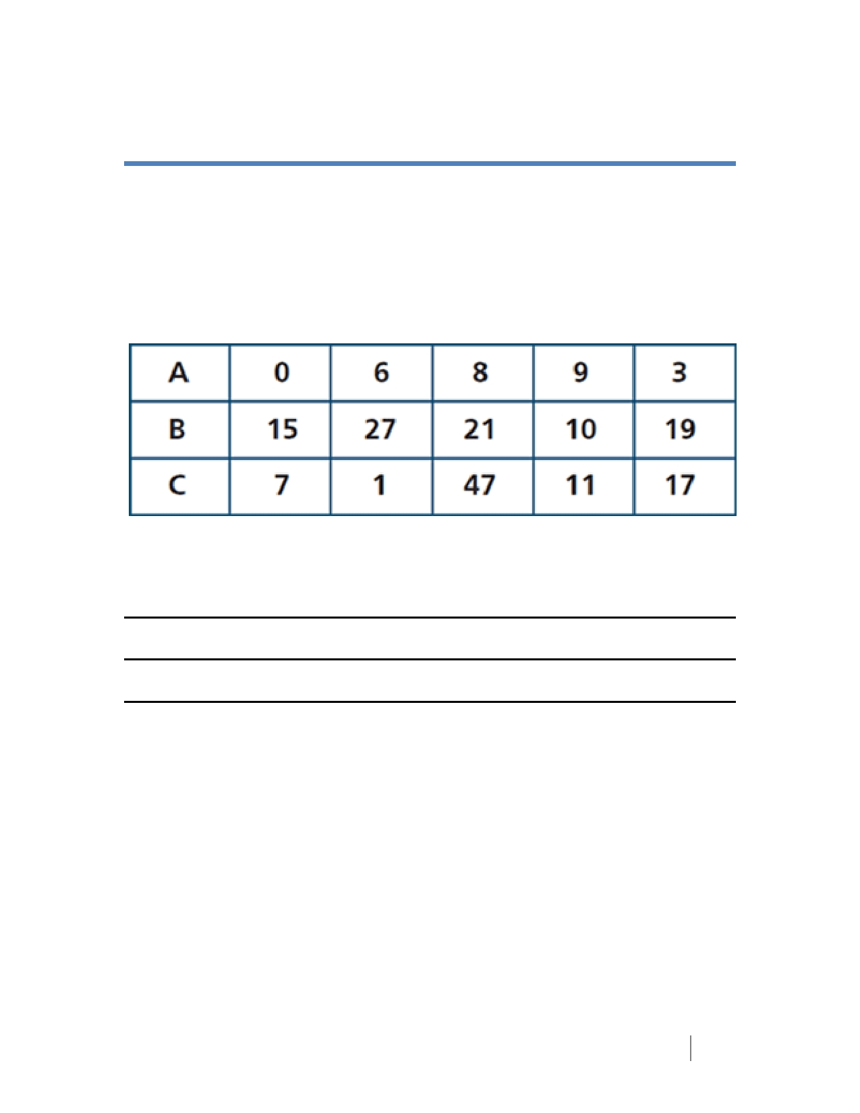

16, 14, 38

In this puzzle, three numbers: 16, 14 and 38, need to be assigned to one of the rows
of numbers below. To which row should each number be assigned?
(Hint: This is not a mathematical problem. The numerical values are irrelevant.)

Your Answer:

A: Reason:

B: Reason:

C: Reason:
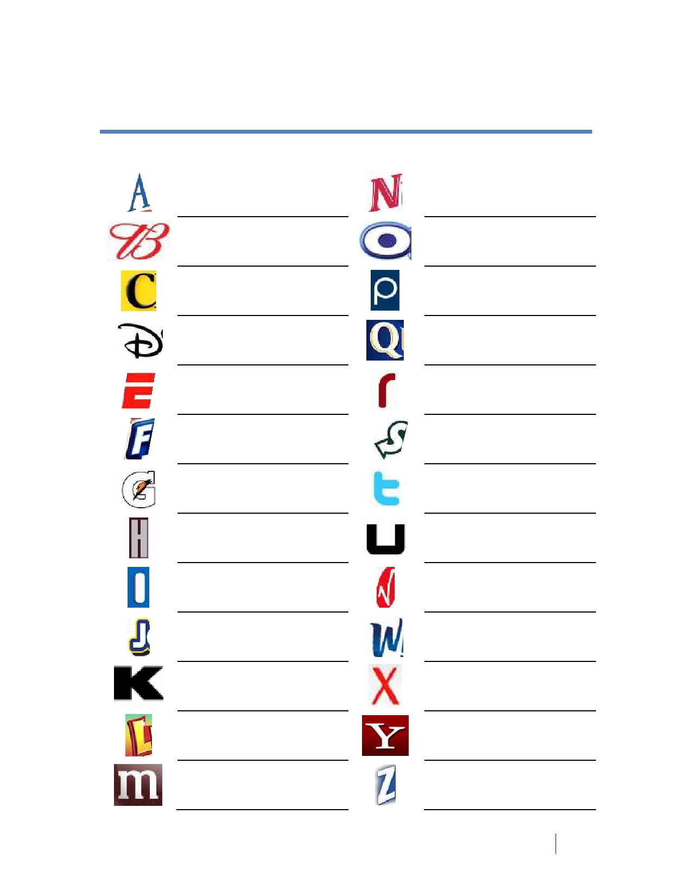

Alphabet Brands

Creative Problem Solving

You're driving along on a wild, stormy night. Rain is pounding on the windshield of
your car. You pass a bus stop and see three people waiting for the bus: (1) An old
lady who is ill, possibly about to die. She's obviously in great distress. (2) An old
friend who once saved your life. You would enjoy spending time talking with him.
(3) Your soul mate, a person you have been dreaming about all your life, truly an
answer to a lifelong prayer.

To which of these would you offer a ride on this awful night -- knowing that you
have room for only one passenger in your car?

Nine Dots: “Think Outside the Box”

• Use four straight lines to connect all nine dots on the diagram below.
• You may not remove your pencil from the paper when you begin drawing the
lines.
• You may not retrace a line and count it as one line.
• You may not use curved lines.

Wordles

cycle
cycle
cycle ________________________________

ALLworld ________________________________

Ban ana ________________________________

Stand ________________________________
I

YouJustMe ________________________________

Side Side ________________________________

Alphabet Sequence

A EF HI

BCD G J

BLIND LINE UP

Your goal is to line up in alphabetical order by first name – before 2 minutes is up.

- The catch is that no one can speak.

- After 2 minutes, each person will stay where they are. Starting at the beginning of
the line, each person will say their name.

PREVENTION ROCK BAND

Opening Activity (Option 1)
Form a Band Cards
Print copies of the cards and cut. Ensure that each participant has a card for the Opening Activity.
Keyboard Player | Drummer
Guitar Player | Singer
Keyboard Player | Drummer
Guitar Player | Singer

Group Breakout #1 (Group Norms)

COLOR POST-ITS

- Listen for instructions from facilitator.

- Form 5 groups by finding the other participants with the same color post-its.

Group Breakout #2 (Alphabet Brands)

The clothes you’re wearing

Quickly find a partner by matching yourselves up with someone who is wearing the same color or same pattern.

Group Breakout #3 (Elements of Effective Collaboration)

Cast Ensemble

Break into 5 teams/groups by using the Ensemble Cast Cards assigned by facilitator.

- There are five sets of ensembles with six characters each (X-Men, The
Jacksons, Peanuts Gang, Harry Potter Cast, and American Idol Judges).

- You cannot look at your card.

- Lift up your card and place in on your forehead – picture facing out.

- You are a part of a famous group and you must find the other members of your group.

- You may not look at your pictures.
- You must find out who you are by mingling with each other. You can give clues to each other and ask yes/no questions – but you may not tell/provide the name of the person or the name of the ensemble cast.
- Once you figure out who you are, search for other members of your ensemble.
- Once the ensemble finds each other, find a table and sit down together.

Group Breakout #4 (Adolescent Development)

Age-Range

- On a post-it note, write the age range of the students you teach or will teach in your YPE program.

- Form groups of 3-5 people based on age range.

- Group members must have written down the same age range, within a 1 year variance on either end.

- Once you are grouped, find a table and sit down.

Group Breakout #5 (Facilitation Skills)

Deck of Cards

- Facilitator will distribute a card to each participant.

- Form a group with everyone else who has the same number.

- Once groups are formed, find a table and sit down.

Group Breakout #6 (Evaluation Plan)

PB&J

- What are the three ingredients in a PB&J sandwich?

- Form groups by making a sandwich with ingredient(s) assigned by facilitator.

