[Organization Name] Social Media Strategy
Implementation Date
Last Reviewed/Updated Date
Adapted from:
http://keyhole.co/blog/social-media-strategy-template-download-5-examples/

Overall Goals

The overall goals of this social media strategy are:

1.

2.

3.

Objectives

The social media team will work to reach the first overall goal, [insert goal #1], by working to meet the following objectives:

1.

2.

The social media team will work to reach the first overall goal, [insert goal #2], by working to meet the following objectives:

1.

2.

The social media team will work to reach the first overall goal, [insert goal #3], by working to meet the following objectives:

1.

2.

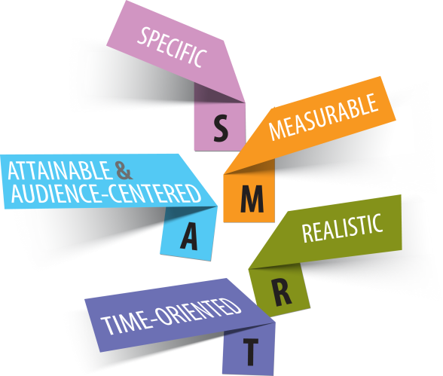
PRO TIPS:
- Strong goals and objectives help
guide your actions on social media,
ensure continuity, and (most
important) help to measure
your success.
- The objectives should adhere to the
SMART method — they need to be
specific, measureable, attainable,
relevant and time-based.

Target Audiences

We will target the following primary audiences:

Name | Describe the audience.  Include demographic information, what types of things/activities/content they like, and why they would want to engage with you.

When applicable and/or possible, we will target the following secondary audiences:

Name | Describe the audience.  Include demographic information, what types of things/activities/content they like, and why they would want to engage with you.

PRO TIPS:
- Knowing your target audience helps you deliver content that your audience will like (and engage with!) on the channels where they are most likely to see it.
- Don’t know where your audience is on social media or what types of content they want to see? ASK!
  - Distribute a survey, conduct a focus group, or send an e-mail asking about your audience’s preferred channels and what content they want to see from your social media channels.

Self-Analysis

A quick audit of current social media activity will
- Identify efforts to continue (what’s working) and areas to improve (what’s not working).
- Find “quick fixes” (e.g., resize profile photos, verify Facebook page) to improve your performance on social media channels.
- Establish a baseline to measure against and celebrate improvement!

Facebook

URL
Fans (people who have liked your page)
Last Activity
Posting Frequency
Top 3 Posts Last Month
Reach
Engagement (clicks, reactions, comments, shares)
Top Fans/Engaged Fans

Additional questions to ask:
- Has our page been verified?
- Is our page designated as a nonprofit page?
- Is our profile filled out completely? Is it accurate?
- Is our profile picture and cover photo appropriately sized?

Notes:

Twitter

URL
Followers
Following
Likes
Posting Frequency/Times
Top 3 Posts Last Month
Engagement (retweets, mentions, shares)
Top Followers

Additional Questions to ask:
- Is our profile filled out completely?
- Are we using all three image locations on Twitter?

Review your followers:
- Report fake accounts
- Delete pages overrun with spam

Notes:

Other

URL
Follower Count
Top Post Last Month
Engagement Rate
Posting Frequency
Click Rate
Top Followers

Notes:

Voice/Tone: Your Online Persona

Content Type
What are you writing?
Target Audience
Who are you talking to in this scenario?
Reader Feelings
What is the reader feeling when he or she is in this scenario?
Your Tone Should Be
What adjectives describe how you should sound in this scenario?
Write Like This
Give a brief example of how the writing should sound.
Tips
Include best practices or other information that should be included when writing for this scenario.

Notes:

Content Strategy

PRO TIPS:
- Each channel requires its own unique, ongoing content strategy to reach specific goals.
- Keep your target audiences in mind when determining your content strategy.
  - For example, would a group of teenagers respond to a formal or informal tone?
  - What types of content has the audience responded to in the past?
- This section is not set in stone. You will plan your strategy, implement it, review your metrics, and revise your strategy continuously.

We will use the following channel-specific content strategy to communicate with target audiences as we work to reach our goals and objectives.

Notes:

Channel 1:

Target Audiences
Relevant Goals
Relevant Objectives
Content Tone
Content Mix/Content Types
(e.g., 5-3-2 model)
Posting Frequency
Sharing Times
Primary Sources for Curated Content
Main Topics or Keywords to Monitor for Curated Content
Tactics We Want to Try (e.g., campaigns, live video)
Include activity, duration, goals, and expected results
Our social media content calendar is here: [Add Link]
Our file containing old posts and images is here: [Add Link]

Channel 2:

Target Audiences
Relevant Goals
Relevant Objectives
Content Tone
Content Mix/Content Types (e.g., 5-3-2 model)
Posting Frequency
Sharing Times
Primary Sources for Curated Content
Main Topics or Keywords to Monitor for Curated Content
Tactics We Want to Try (e.g., campaigns, live video)
Include activity, duration, goals, and expected results

Channel 3:

Target Audiences
Relevant Goals
Relevant Objectives
Content Tone
Content Mix/Content Types (e.g., 5-3-2 model)
Posting Frequency
Sharing Times
Primary Sources for Curated Content
Main Topics or Keywords to Monitor for Curated Content
Tactics We Want to Try (e.g., campaigns, live video)
Include activity, duration, goals, and expected results

Engagement: Monitoring and Leveraging Influencers

Use a social media monitoring tool (e.g., Hootsuite) or manually search for these terms on a regular basis:
  - Your organization
  - “Competing” organizations
  - Misspellings of terms relevant to your brand
  - All of these phrases with positive terms such as “can” and negative terms such as “don’t”
- Identify topic influencers, similar organizations, and individuals who frequently interact with your page. Follow those that share your values, mission, and provide useful information for your audience. Search for and share their relevant content.

We can identify opportunities for engagement and earn followers by continuously monitoring the following terms on our social channels:

Organization Name
Include alternate spellings or acronyms
“Competing” Organizations
Include alternate spellings or acronyms
Common Misspellings of Relevant Terms
Positive and Negative Terms
Individuals We Want to Follow and Engage with
Organizations We Want to Follow and Engage with

Engagement: Malicious Comments and Community Guidelines
Offensive, hateful, or malicious comments can damage our reputation and the relationship we have with our audience. This section outlines how we will handle these types of comments on our posts.
We will take the following action(s) for comments that are offensive, inappropriate, or spam:
We will take the following action(s) if the same user continues to post offensive material to our social media accounts:
PRO TIPS:

- Establish community guidelines or a commenting policy to prevent malicious comments and to assure your audience that these types of comments will be deleted without consideration.
  - Example community guidelines: http://www.cdc.gov/socialmedia/tools/commentpolicy.html; http://www.drugfree.org/comment-policy-guidelines/
- Post your community guidelines online and share on your social media channels periodically.
  - Example: https://www.facebook.com/notes/travel-oregon/facebook-comment-policy/10150197243034720/
Our social media community guidelines are here: [Add Link]

Engagement: Responding to Audience Comments
Quick and helpful responses are necessary for engagement on social media. Our team will monitor our social media channels [X times per day]. We aim to respond to [X%] of comments and mentions received on our social media channels within [X time].

Below are responses our team can use, adjust, and reference when facing common situations.

Scenario | Common Examples | Set Responses
Praise
Complaint
Personal Stories
Direct Question
Misinformation
News Event

Evaluation
On a monthly basis, review metrics and answer the following questions:
1. What is working and in what way?

2. What is not working and why is it not working?

3. How will we amplify and do more of what is working?

Roles, Responsibilities, and Standard Operating Procedures
This section designates responsibilities according to key functions in our social media strategy. It also outlines required approvals.

Process | Activities | Staff Involved and Role | Recommended Timing
Content Development | - Solicit input on monthly content.  - Develop text and accompanying graphics to populate the page for one month.  - Obtain approval for text and graphics.  - Develop and record videos.
Posting | - Enter all content into Hootsuite (or use Facebook’s scheduler) and schedule dates and times when content should be posted.  - Post additional, curated, or shared content (unscheduled).
Monitoring and Responding | - Monitor page for user comments X times daily.  - Respond to posts using preapproved language or gain approval for responses.  - Consult experts to respond to misinformation.  - Remove inappropriate comments.
Record Keeping | - Record metrics on post engagement in content spreadsheet.  - Archive posts and graphics.
Evaluation | - Download metrics data and review.

Notes:

Budget
Ads and Boosted Posts

Channel | Cost Per Month

Total Cost for Ads and Boosted Posts:

Analytics and Management Tools

Tool | URL | Applicable Networks | Cost Per Month

Total Cost for Analytics and Management Tools:

New Staff

Title
Duties
Years of Experience
Salary Range

Total Cost for New Staff:

Total Cost for Ads, Tools and New Staff:

