Opioid Safety
Provider Brochure

Partnership for Community Care (P4CC)

A regional partnership of primary care providers, hospitals, departments of social services, and community organizations. We are one of the physician-led networks participating in the statewide Community Care of North Carolina (CCNC) program.

Our Mission: Improving access, maintaining quality, reducing costs of medical care in Guilford, Rockingham and Randolph Counties.

Our purpose: Identifying and minimizing barriers to healthcare by helping primary care providers in our network to better utilize evidence-based disease state management guidelines. Providing Care Management services to patients to reinforce what their provider's treatment plan is and to better manage their chronic conditions.

Empowering our community to improve the quality of their healthcare
www.P4CommunityCare.org

Opioid Safety Program Manager
opioidsafety@p4care.org
(336) 235-0930

http://www.p4communitycare.org/programs-initiatives/PL/

1802JP

O

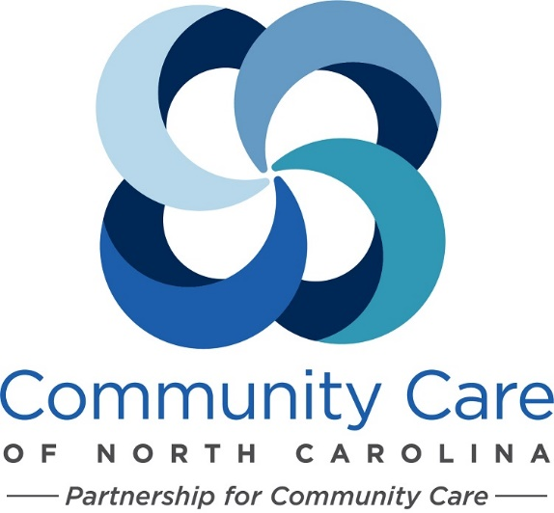

Serving Guilford, Rockingham, and
Randolph Counties

What is the Opioid Safety Program

In response to some of the highest drug overdose death rates in the state, Partnership for Community Care (P4CC) provides education and individualized care management for patients taking opioids.

The issue of chronic pain represents a complex interaction between biological, psychological and social variables. While prescription painkillers, especially opioids, can be used effectively in the treatment of chronic pain, when used incorrectly they can be deadly. Epidemic levels of unintentional deaths by poisoning, particularly from opioids, are having a profound effect across the U.S., and even more so in North Carolina communities, where death rates exceed the national average.

Goals of the Opioid Safety Program:
- Reduce opioid-related overdoses
- Optimize treatment of chronic pain
- Reduce inappropriate use of opioids

Opioid Safety coalition stakeholders include:

Community Care of North Carolina (CCNC), The North Carolina Hospital Association, The North Carolina College of Emergency Physicians, Local hospitals and emergency departments, Local health departments, Primary care providers, Law enforcement, EMS and others.

How Can We Help

Practice & Provider Educational Materials

- Community Care of North Carolina
https://www.communitycarenc.org/population-management/opioid-safety/

- NC SBIRT
http://ncsbirt.org/
Offering annual questionnaires, DAST and AUDIT screening tools, in both English and Spanish

- Pain Reference Cards

- Video Resource
Understanding the Pain Patient- Treating Complex/Difficult Pain Patients
http://governorsinstitute.org/opioid/training-and-cme/training-videos/

Resources

SAMHSA Opioid Overdose Prevention Toolkit
http://store.samhsa.gov/product/Opioid-overdoses-prevention-toolkit/SAM13-4742

Community-Based Overdose Prevention and Naloxone Distribution Program Locator
http://hopeandrecovery.org/locators/

Prescribe to Prevent
http://prescribetoprevent.org/video

Naloxone Distribution North Carolina
Distribution areas, Pharmacies that distribute,
Good Samaritan Law and Standing Order
www.naloxonesaves.org

