Training Outline

Implementing Environmental Strategies and Effective Project Management
Thu Nov 1st 10:00am - Fri 2nd 4:00pm
NC TTA Center, 7830 North Point Blvd #205, Winston-Salem, NC 27106, USA

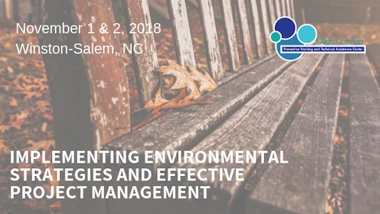
The training on Day One will start at 10:00 a.m. and on Day Two will start at
8:30 a.m.
Training Description
The Implementing Environmental Strategies and Effective Project Management Training prepares Block Grant Providers, Leaders and Managers to implement Evidence-Based Environmental Strategies using Effective Project Management Strategies and Methods. This training will increase participants’ knowledge and skills related to planning, managing, facilitating, evaluating of Environmental Strategies and other Projects.
Learning Objectives – Day 1
By the end of the training experience participants will:
- Identify best practices related to environmental strategy implementation
- Compare historical patterns of what works in strategy implementation and lessons learned
- Learn about tools that support the implementation of evidenced based practices
Learning Objectives – Day 2
- Understand the basic principles of project management
- Learn about the tools of project management
- Become familiar with the role of the project manager
- Analyze your very own project management style
Audience
This training is designed for new Prevention Staff and Leaders who are new at leading Environmental Strategies or other Projects in all types of settings.
Skill Level
The event is intended to serve the professional needs of entry level and moderately experienced professionals or anyone interested in improving their ability to better manage projects.
Certification Credit Status
An application for continuing education credit has been submitted to the NCSAPPB. Attendees will receive their certificate of attendance/credit via email after the training event.

